Marie (Millet) Montz
September 30, 1894 – November 7, 1976

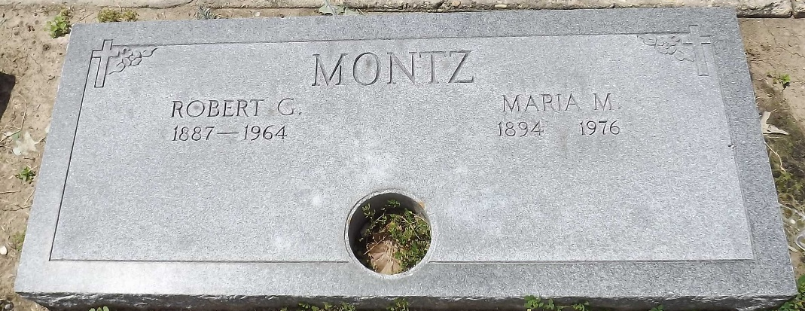
Photo by Mary Agnes Hammett

MONTZ
Marie Millet Montz, on Sunday, November 7, 1976 at 9 pm., beloved wife of the late Robert G. Montz, mother of [Albert] Lawrence (Bill) Montz, Sulphur, La, sister of Mrs. J. S. Perilloux of Montz, La, grandmother of Mrs. Charles Anderson of Lake Charles, La, Mrs. Robert Davidson of Sulphur, La, and John F. Montz of Sulphur, La. Also survived by 6 great grandchildren and a host of nieces and nephews. Age 82 years, a native and resident of Montz, La.

Relatives and friends of the family are invited to attend the funeral services from Millet Funeral Home, Laplace, La, on Tuesday, November 9, 1976 at 10 am. Followed by religious services at St Joan of Arc Catholic Church, Laplace. Interment in St Peter Cemetery, Reserve, La.
The Times-Picayune, New Orleans, Louisiana
November 9, 1976, p. 12

