Noemie Montz
May 25, 1896 – February 18, 1948

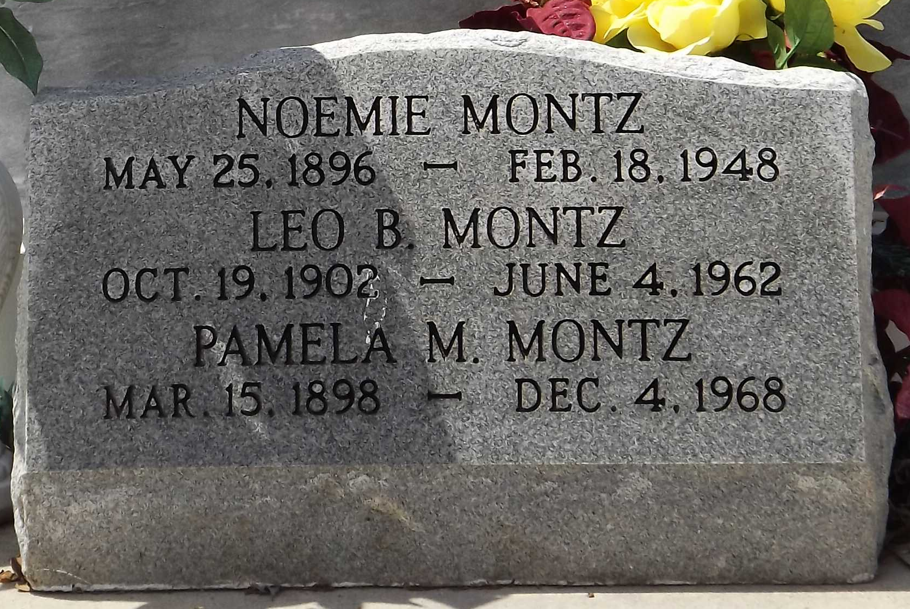
Photo by Mary Agnes Hammett

Noemie Montz died Wednesday, 18 Feb 1948, at 1:50 o'clock a.m.

She was the daughter of the late Camille Montz and Blanche Madere and the sister of Pamela and Leo Montz. She was age 51 years.

Relatives and friends of the family, also employees of Westco Water Paint Company, Goodhope, Louisiana, are invited to attend the funeral, which will take place from the residence at Montz, Louisiana, on Thursday, 19 Feb 1948 followed by religious services at St Peter's Church, Reserve, Louisiana. Interment in St Peter’s Cemetery, Reserve.

Times-Picayune, The (New Orleans, Louisiana)
February 19, 1948, p. 2

