Numa Jacques Montz
February 29, 1844 – June 25, 1922

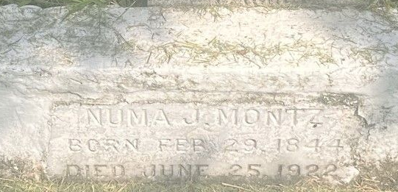

"Thursday afternoon at 5:30 o'clock, the inevitable death, always on the alert to remove our dear ones, claimed one of Saint John's oldest and most highly esteemed and honored citizens in the person of Mr. Numa Montz, a resident of Laplace, aged 76 years. The funeral services were held at Saint Peter's Church the next day, amid a large concourse of sorrowing relatives and friends. Deceased leaves to mourn his sad demise four sons - Octave, William, Armand and George - six daughters - Mrs. Elias Madere of Reserve, Mrs. George Lambert of St Rose; Misses Corinne, Marie, Blanche and Toussine."
L'Observateur, LaPlace, Louisiana
Saturday 27 May 1922
His succession is found in the records of St John the Baptist Parish, 24th Probate Court, File #287-A, under the name Jacques Numa Montz. His Louisiana Death Certificate notes his death as 26 May 1922 at age 76 with burial in St Peter Cemetery, Reserve, also on 26 May 1922. Further notes that he was a native of St John the Baptist Parish and had lived in Laplace of the last 27 years.
His baptism record is found in the records of St John the Baptist Church, Edgard, in Baptism Book 6, p 163: Jacques Montz born 29 Jan 1846 and baptized 1 May 1846. His funeral record is found in the records of St Peter Church, Reserve, Funeral Book 3, p 203: Numa Montz died 25 May 1922 and burial was in St Peter Cemetery on 26 May 1922. Note that birth and death dates portrayed on his grave marker differ with these dates.
According to his Louisiana Confederate pension application filed 6 Dec 1912, he was born in Laplace, St John the Baptist Parish, and served as a Private, Company E, 22nd Consolidated Louisiana Infantry, CSA. He enlisted 7 Sep 1864, surrendered at Citronelle, Alabama, on 4 May 1865 and was paroled on 12 May 1865 at Meridian, Mississippi.

Researched by Dwayne Montz

