Octave Alexis Montz
July 17, 1872 – August 4, 1940

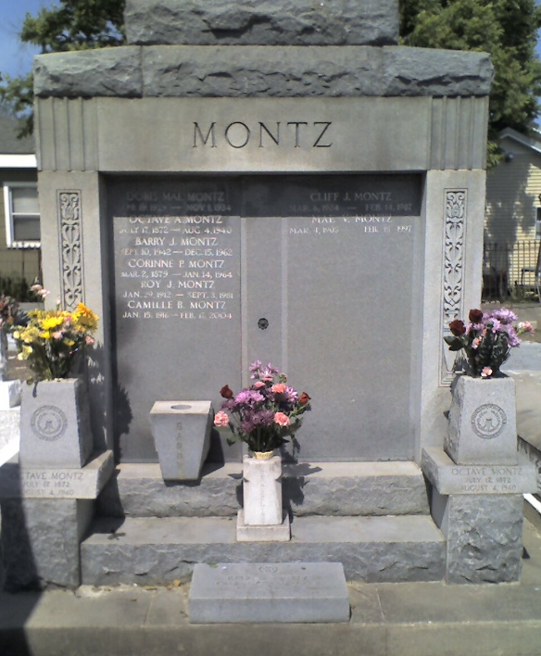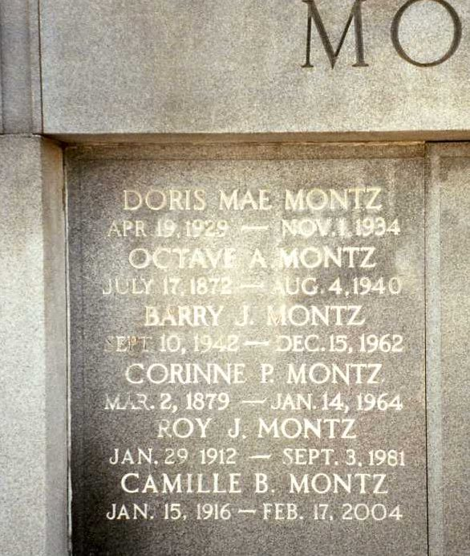
Photo by Dwayne Montz

With the passing of Mr. Octave A. Montz, who died Sunday [4 Aug 1940] morning at 9:30 o'clock, at his home in Laplace, in the 4th ward of this parish, after a lingering illness, a long and useful life was brought to a close.
Deceased, who was 68 years old, was well identified here in the mercantile business having conducted the Rock Store for some 40 years in the same place, and was distributor of Jax Beer for the past 12 years. Being born in Reserve he moved to Laplace where he opened a store and kept it open continually for 40 years.
Mr. Montz was a great lover of home and family - his devotion was indeed remarkable. He was possessed of a jovial disposition and to know him was to love him. His wife, née Corinne Périlloux, is left to mourn his passing. As time rolls by she will miss his faithful love, his constant companionship, true and sincere friendship, that had weathered storms and trials through the years. He was always a pleasant, unassuming person, who was readily liked by those with whom he come in contact.
About three months ago, Mr. Montz was stricken with a paralytic stroke and rushed to Hotel Dieu in New Orleans from where he returned home one month ago and since then had not been able to leave his home until the final end came Sunday morning.
Being a charter member of John A Reine Camp No 504, Woodmen of the World, he had received a button marking the distinction of being a Woodmen for 25 years, his funeral services which were conducted by Rev. A. J. Lieux in St Peter's Catholic Church Monday [5 Aug 1940] afternoon at 4 o'clock, were largely attended by relatives, friends and acquaintances, who had come to pay their last respect to his man of good.
To lament his demise he leaves two sons, Clifford and Roy Montz; three daughters, Mmes. Clarence Madère, Eddie Jacob and Percy Hébert, all of Laplace; and five grandchildren. He is also survived by 3 brothers, William, George and Armand Montz of Laplace; and four sisters, Miss Blanche Montz of Laplace; Mrs. Elisée Madere of Reserve; Mrs. Geo. Lambert of St Rose; and Sister Mary Genevieve of New Orleans.
The family desire to extend their heartfelt and sincere thanks to all relatives, friends and acquaintances who rendered assistance and showed sympathy during the deceased's illness, death and funeral. Also to the Boy Scouts who so ably conducted the parking of automobiles at home during the wake and at church during the services.

L’Observateur, LaPlace, Louisiana
August 10, 1940

