Pamela Mary Montz
March 15, 1898 – December 4, 1968

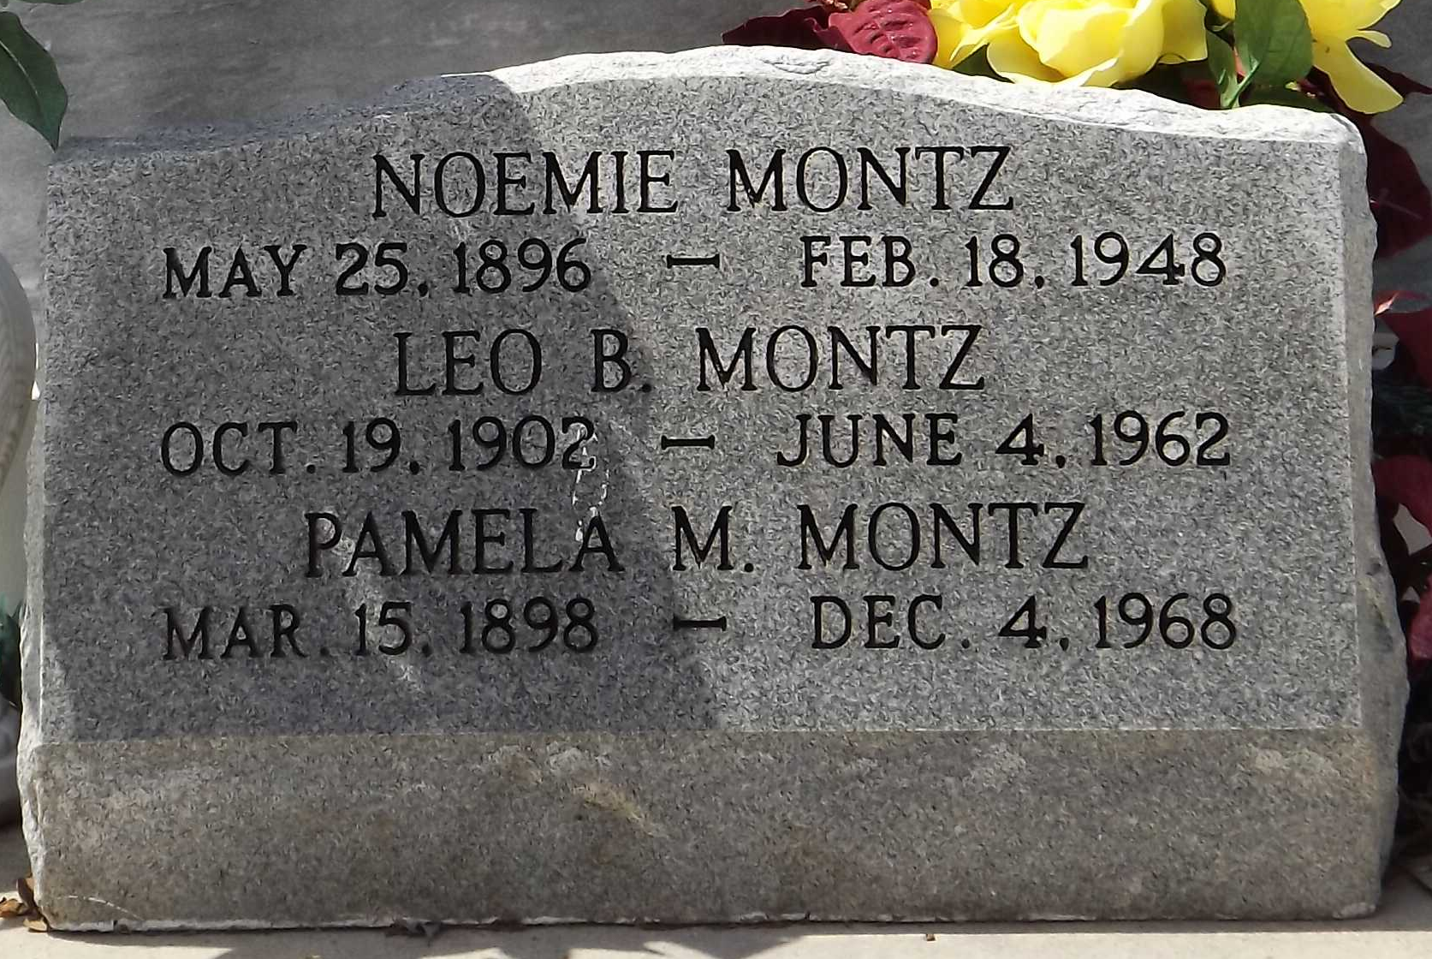
Photo by Mary Agnes Hammett

Pamela Mary Montz died on Wednesday, 4 Dec 1968 at 10:55 o'clock a.m.

She was the daughter of the late Camille Montz and Blanche Madere and the sister of the late Noemie and Leo Montz. She was age 71 and a native and resident of Montz, Louisiana.

Relatives and friends of the family are invited to attend the funeral services from Millet Funeral Home, Laplace, Louisiana, on Friday, 6 Dec 1968 with religious services in St Joan of Arc Church, Laplace. Interment in St Peter Cemetery, Reserve, Louisiana.

Times-Picayune, The (New Orleans, Louisiana)
December 5, 1968, p. 36

