Pierre Rene Montz Jr.
December 2, 1895 – December 20, 1972

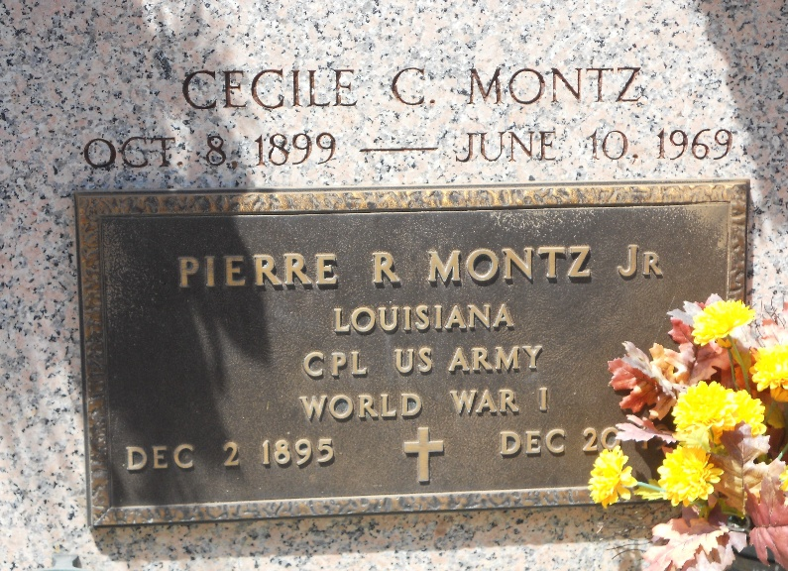
Photo by Team T-Lo
Age 77 years, a native of Reserve, Louisiana, and a resident of Chalmette, Louisiana, for the past 23 years.

Husband of Edna Ross and the late Cecile Candies by first marriage. Brother of Eleanore Montz, Mrs. Denise Bourg, Mrs. Marcelle Landry, Mrs. May Keller and Carl Montz, all of Reserve, and Mrs. Juliette Bressler of Chalmette.

Services were Friday 22 Dec 1972 at St Peter Church, Reserve, with interment in St Peter Cemetery.

Times-Picayune, New Orleans, Louisiana
December 22, 1972

