Quincy Edward Montz
October 26, 1919 – April 15, 2012

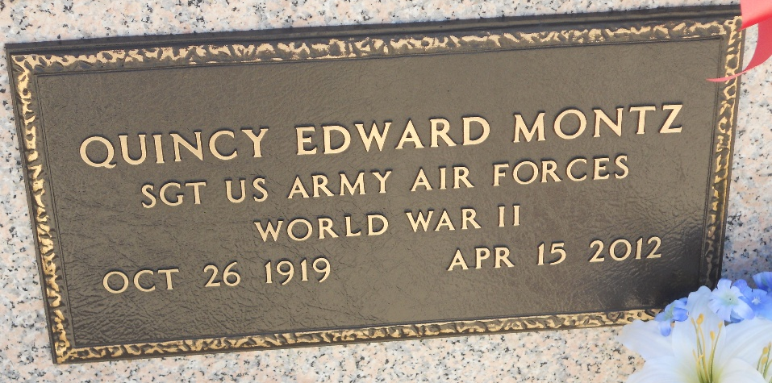
Photo by Team T-Lo
Quincy Edward Montz passed away on Sunday, April 15, 2012 at the age of 92. He was born in Lions, Louisiana and was a resident of Reserve, Louisiana. He was a resident of the Southeast Louisiana War Veterans Home for the last 10 months.
Beloved husband of Beverly Louque Montz. Father of Drema Montz Millet (Byron) and Mark Quincy Montz (Dorothy). Grandfather of Lisette Webre, Byron Millet Jr., Jeremy Coplen Montz and Jordan Alexander Montz. Great-Grandfather of Christopher and Lauren Webre, Owen and Jenna Millet, and Addison and Landon Montz. Also survived by a sister, Pearl Montz Madere and a host of nieces and nephews.
Preceded in death by his parents, Maurice Montz and Virginia Cambre Montz, 4 brothers: Dan, Elmore, Armand and Floyd, and 3 sisters: Vivian, Lillian, and Yolande.
He served in the US Army Air Corps for 3 years during WWII. He was employed by Godchaux Henderson Sugar Company and was an active member of the Reserve Lions Club for 50 years. He served as President and Secretary of the Godchaux Henderson Credit Union and was named a Peoples Health Champion in 2009.
Relatives and friends are invited to attend services. Visitation is at St. Peter Catholic Church, Reserve, Louisiana on Thursday April 19, 2012 from 9:00-11:00 AM, followed by a Funeral Mass at 11:00 AM. Burial in St. Peter Cemetery. In lieu of flowers, Masses will be appreciated. Arrangements by Millet-Guidry Funeral Home, LaPlace, LA.

Times-Picayune, New Orleans, Louisiana
April 17-18, 2012

