Robert Gervais Montz
April 29, 1887 – April 6, 1964

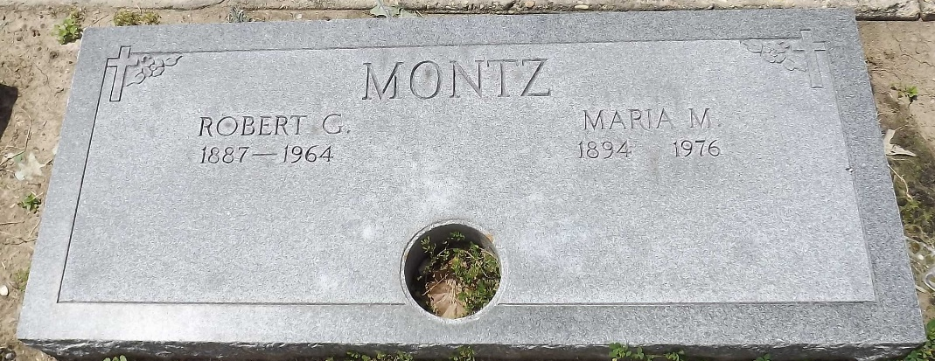
Photo by Mary Agnes Hammett

MONTZ-At his residence, Montz, La, on Monday, April 6, 1964, at 2 o'clock a.m., ROBERT GERVAIS MONTZ, beloved husband of Marie Millet, father of [Albert] Lawrence Montz of Lake Charles, La, grandfather of Mrs. Charles Anderson and John F. Montz of Lake Charles, La, Mrs. Robert Davidson of Lafayette, La, brother of the late Rudolph Montz and Miss Rosie Montz, also survived by 2 great grandchildren, age 76 years, a native of Reserve, La (sic - really Laplace, La), and a resident of St Charles Parish for the past 70 years.

Relatives and friends of the family, also employees of the Shell Oil Company are invited to attend the funeral. Services from the Alexander Funeral Home, Norco, La, on Tuesday, April 7, 1964, at 10 o'clock a.m. Religious services at Sacred Heart of Jesus Church, Norco, La. Interment in St Peter's Cemetery, Reserve, La.
The Times-Picayune, New Orleans, Louisiana
April 7, 1964, p. 2

