Roger Francis Montz
1903 – July 18, 1931

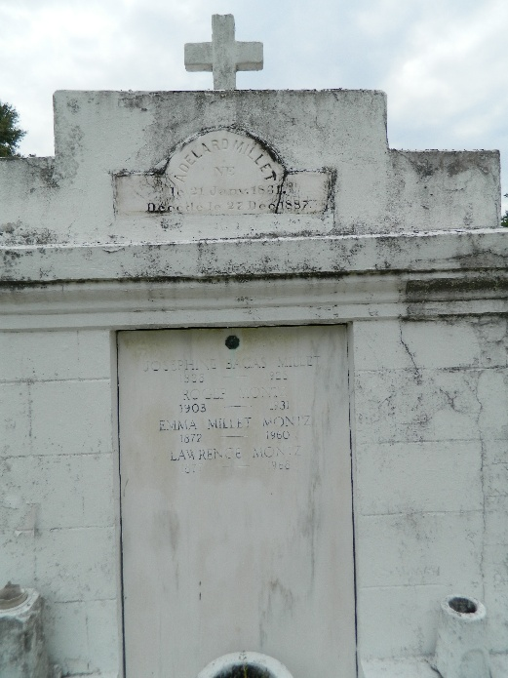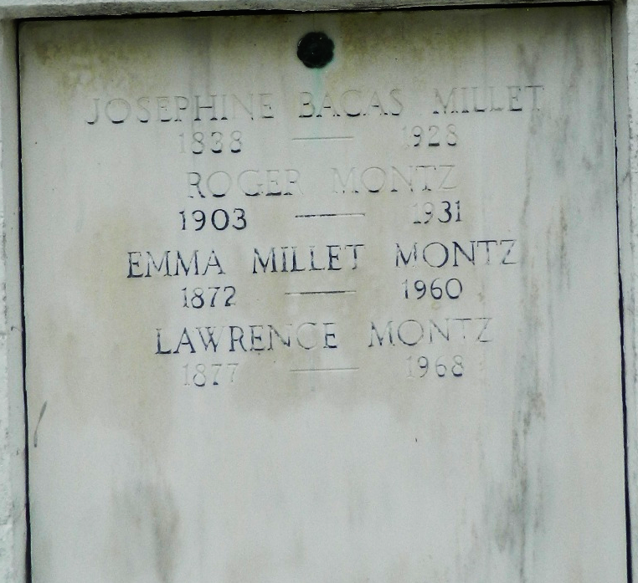

Roger F. Montz died Saturday, 18 Jul 1931 at 3:30 pm in his 23rd year.

He was the husband of Julie Lefort and the son of Emma Millet and Lawrence Montz. Brother of Mrs. W. G. Baudouin and Yvonne, Claudia, Lance and Royal Montz.

Services were Sunday, 19 Jul 1931 at St Peter Church in Reserve, Louisiana, with interment in St Peter Cemetery, Reserve.
The Times-Picayune, New Orleans, Louisiana
July 19, 1931

