Roy P. Montz
February 14, 1916 – March 22, 1945

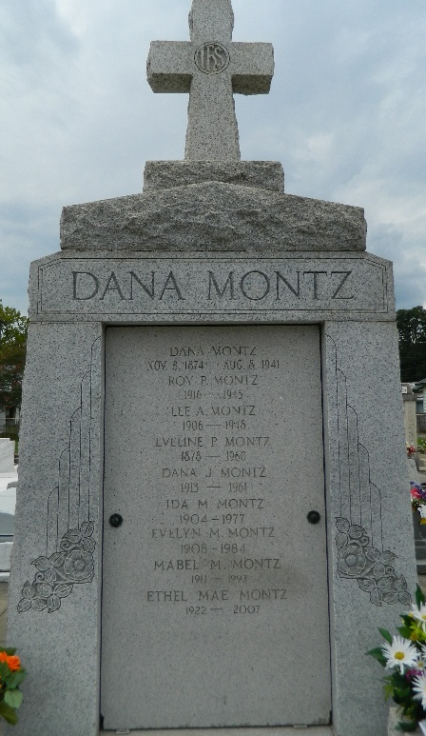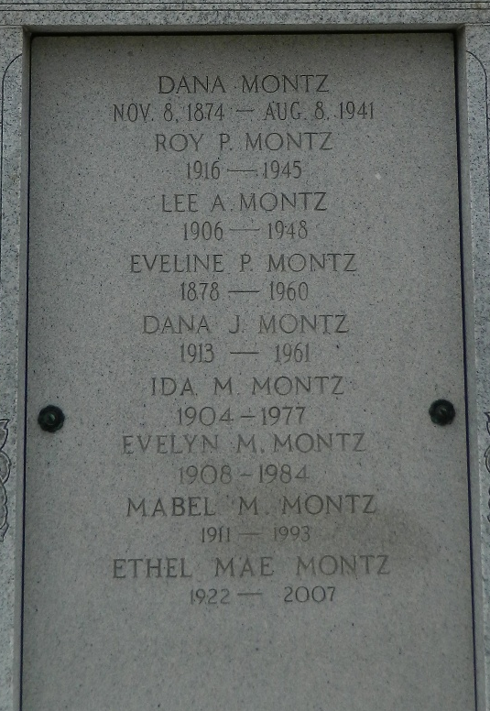

MONTZ – In the service of his country in Germany on March 27, 1945, Cpl. Roy P. Montz, Medical Detachment, son of Eveline Perret and the late Dana Montz; brother of Lovincy, Lee, Dana, Ida, Evelyn, Mabel and Ethel Mae Montz; uncle of Carroll and Rose Mea Montz; aged 29 years.
Relatives and friends of the family, also V.F.W. Reserve Post No. 5004, American Legion No. 159, and employes of Godchaux Sugars, are invited to attend the funeral, which will take place at St. Peter’s church, Reserve, La., on Tuesday morning, April 20, 1948, on arrival of 8:32 o’clock train at Y. & M.V. Depot, Reserve, La.
The officers and members of American Legion Post No. 159 and V. F. W. Post No. 159 are requested to meet the 8:32 o’clock train at the Y. & M. V. Depot, Reserve, La., on Tuesday morning, April 20, 1948 for the purpose of escorting the body of our late comrade, CPL. Roy P. Montz.
The Times-Picayune, New Orleans, Louisiana
April 17, 1948, p. 2

