Sally A. Montz
October 10, 1937 – November 17, 2013

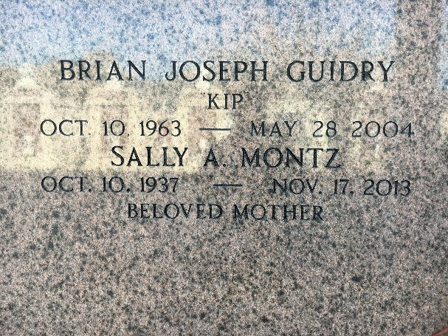
Photo by Team T-Lo

Sally Montz died on Sunday November 17, 2013.
Beloved mother of Maria Guidry (Cruzita), Jane Guidry (Paul), John Galen Guidry (Donya) and the late Brian (Kip) Guidry. Also survived by 6 grandchildren and 6 great-grandchildren. Daughter of the late Harry and Leola Ress Montz. Sister of Joe Montz, Nancy Guillot, Jeanie Prima and Theresa McCarthy.
She was a volunteer at River Parish Hospital and the Adult Literacy Program, retired from the St. John School Board. Age 76. A native and resident of Reserve, LA.
Relatives and friends are invited to attend Memorial Services. Visitation at St. Peter Catholic Church, Reserve, LA on Saturday November 23, 2013 from 9:00 am to 11:00 am, followed by Mass. Burial in St. Peter Cemetery.
TheNewOrleansAdvocate.com
Nov. 20, 2013

