Virginia (Cambre) Montz
October 6, 1887 – March 10, 1973

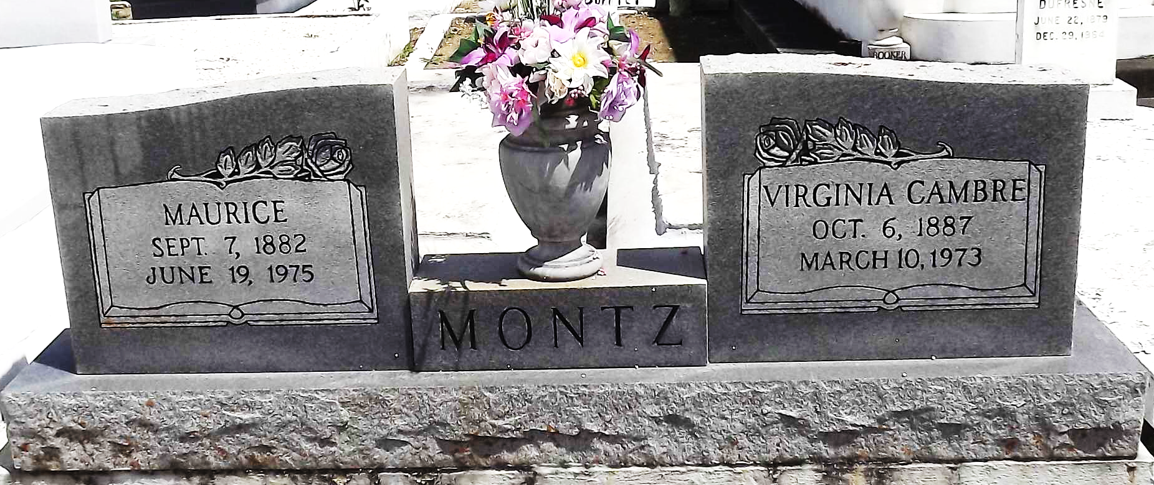
Photo by Mary Agnes Hammett

Mrs. Virginia Cambre Montz, of Reserve, died on Saturday, 10 Mar 1973.
Wife of Maurice Montz and mother of Mrs. Allie (Vivian) Montz and Mrs. Alton (Yolande) Landry both of Houston, TX, Mrs. Albert (Lillian) Griffin Sr. and Quincy Montz both of Reserve, Daniel Montz of Norco, Elmore Montz of Eunice, Mrs. Earl (Pearl) Madere of Laplace and Floyd Montz of Destrehan. She is also survived by 24 grandchildren and 20 great grandchildren. Age 85, a native of Montz, LA, and a resident of Lions, LA.
Burial on 12 March 1973 at St Peter Cemetery, Reserve, LA.
The Times-Picayune, New Orleans, Louisiana
March 11, 1973

