Belinda Marie (Brignac) Moore
November 28, 1949 – November 20, 2024

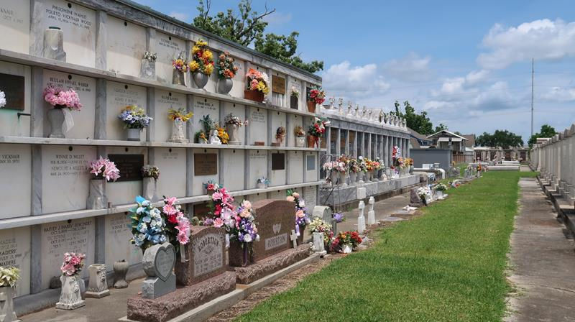

It is with deep sadness that we announce the passing of Belinda Marie Brignac Moore, who departed this life on Wednesday, November 20, 2024, at the age of 75. Born in Reserve, Louisiana, Belinda was a long-time resident of Garyville, Louisiana, where she spent her life surrounded by family and the community she called home.
Belinda was the mother of Twyla Adair (Doug), Robert Moore, and William Brignac (Andrea). She was the grandmother of Lindsey Matherne, Kaitlyn Matherne, Shaina Cockburn (Daniel), Julianne Laborde, Abigale Brignac, Chloe Brignac, and Rylee Brignac, and is also survived by six great-grand-children.
She was the daughter of the late Mildred Millet Brignac and Francis Brignac, Sr. Belinda was the sister of Valerie Everett (Delmas) and the late Francis Brignac, Jr. She is also survived by her goddaughter and niece, Amanda Everett, who may have held the role of favorite niece, perhaps because she was born on Elvis Presley's birthday-a fact Belinda found delightful. Amanda's children, Evan Everett and Maddox and Wyatt Comeaux, also survive her. Belinda was preceded in death by Valerie's children, Abigail Everett and Amie Everett.
Belinda worked at Schwegmann's Grocery for many years, where she was known for her dedication and warm interactions. She also served as a telephone operator and later as a substitute teacher at East St. John High School, roles that reflected her versatility and connection to the community. Belinda volunteered as an election worker and was an active member of St. Hubert Catholic Church, where she participated in parish life.
In her free time, Belinda enjoyed playing bingo and crocheting, hobbies that brought her joy and relaxation. She had a deep love for Pepsi and Oreos, and her grandchildren affectionately called her MawMaw Cookie. She was also a passionate fan of Elvis Presley and cherished a memorable vacation to Graceland with her sons, where she was thrilled to drive her car onto the property. Her favorite football team to root for was Tulane University, except when her son William was playing football-then, she was an enthusiastic East St. John Wildcats supporter.
While Belinda had her own unique way of approaching life, her presence was a steady one in her family's story. Her connection to her roots in Reserve and Garyville was a defining part of her identity. Those who knew her will carry forward memories of shared times and her enduring mark on their lives.
Relatives and friends are invited to honor and celebrate Belinda's life. Visitation will be held on Tuesday, November 26, 2024, from 9:00 a.m. to 11:00 a.m. at Millet-Guidry Funeral Home, 2806 W. Airline Hwy., LaPlace, LA, followed by a Funeral Mass at St. Hubert Catholic Church, 176 Anthony F Monica St., Garyville, LA, at 12:00 p.m. Interment will take place at St. Peter Cemetery, Reserve, LA.
Though she is gone, the ties of family and the moments shared will keep her memory alive in the hearts of those who knew her.

Obituary published on Legacy.com by Millet-Guidry Funeral Home - LaPlace Nov. 25, 2024

