Haley Danielle Moore
April 22, 2011 – May 21, 2016

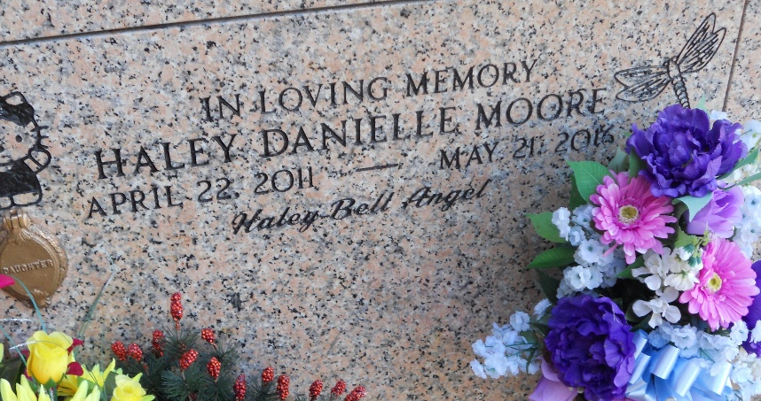
Photo by Team T-Lo

Haley Danielle Moore "Haley Bell" passed away on Saturday, May 21, 2016 at the age of 5. She was a native of Fort Carson, CO and a resident of LaPlace, LA.
Beloved daughter of Corie Lynn Beaumont and Eric Paul Moore. Sister of Ashley Moore and Michael Moore. Granddaughter of John and Debra Beaumont. Great-granddaughter of Diane Clements (the late Edmond Clements) and Ralph Beaumont, Sr. (the late Peggy Beaumont). Niece of Ryan Beaumont (Corinne). Cousin of Carter Beaumont. Also survived by many great aunts, uncles and cousins. Haley's beautiful smile would brighten any room, her spunky, cute, sassy princess 'attitude' was contagious and she will be sadly missed by all who knew her.
Relatives and friends are invited to attend the Funeral. Visitation will be held at Millet-Guidry Funeral Home, 2806 W. Airline Hwy, LaPlace, LA on Wednesday, May 25, 2016 from 6:00 p.m. until 9:00 p.m. and on Thursday at St. Peter Catholic Church, 1550 Hwy 44, Reserve, LA from 9:00 a.m. until 11:00 a.m. Funeral Mass will be celebrated at 11:00 a.m. Interment in St. Peter Cemetery.

The New Orleans Advocate, Louisiana
May 23 to May 30, 2016

