Maureen (Madere) Morales
August 18, 1942 – June 13, 2018

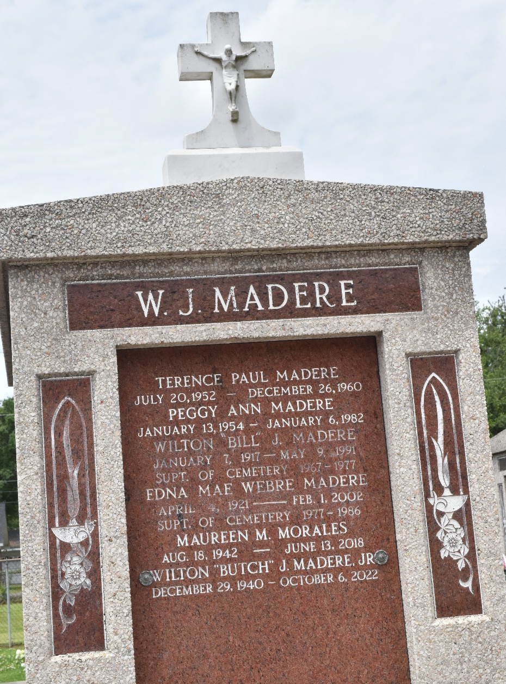

Maureen “Mo” Morales passed away on Wednesday, June 13, 2018 at the age of 75. She was a native of Reserve and a longtime resident of Destrehan. She was a 1960 graduate of Leon Godchaux High School, former Home Interior Decorator and later retired from Yellow Pages by Berry.
Loving mother of Rhonda Morales-Salmeron and Billy Joseph Morales (Betty Jo). Grandmother of Matthew Morales, Ashley Salmeron-Vincent, Joseph Michael Salmeron, Jacob Morales, Meghan Morales and Madison Morales. Great-grandmother of Addison Morales and Zaylen Morales. Loving companion of James “Jim” McCormick. Sister of Wilton “Butch” Madere, Jr., Kathleen M. St. Pierre, Michael Madere, Charles Weber and the late Patrick, Terence and Peggy Madere. She was also preceded in death by her parents, Wilton Madere, Sr. and Edna Mae Madere.
Relatives and friends are invited to attend the Funeral Service at Millet-Guidry Funeral Home, 2806 W. Airline Hwy., LaPlace on Monday, June 18, 2018 at 11:00 a.m. Visitation from 9:00 a.m. to 11:00 a.m. Interment in St. Peter Cemetery.

Millet-Guidry Funeral Home, LaPlace, Louisiana
June 15, 2018

