Frances (Pajeaud) Morton
April 17, 1919 – June 20, 2017

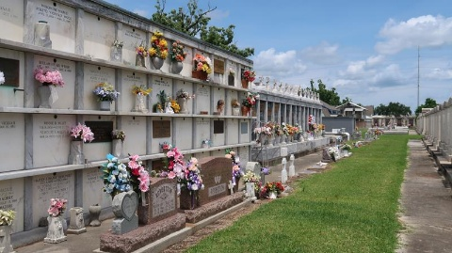

Frances Pajeaud Morton passed away on Tuesday, June 20, 2017 at her home in New Orleans, LA. Daughter of the late Helena Cureaux and Aristide Pajeaud. Wife of the late James J. Morton. Mother of Ty Morton, Gregory Morton (Kate), Donna Morton Alexander (Durham) and Gary Morton (Karen). Sister of Grace Pajeaud Russell, the late Ellena Pajeaud Jamerson, Victoria Pajeaud Eugene, Clairvelle, Aristole, Andoche, Leon, and Anthony Pajeaud. Also survived by 5 grandchildren and a host of nieces, nephews, cousins, other relatives and friends.
Age 98 years. A native of Lions (Reserve), LA and a resident of Metairie, LA. She was a homemaker and school teacher in Jefferson, LA. During WWII she served her country by working in a defense plant in Cleveland, OH as a Riveter building aircrafts. She was dedicated to making her community a better place to live and work with several government officials to support that effort.
Relatives and friends of the family are invited to attend the Funeral Mass at St Peter Catholic Church, 1550 Highway 44, Reserve, Louisiana on Saturday, June 24, 2017 at 10:30 AM. Fr. John Marse, Celebrant. Interment St Peter Cemetery, Reserve, LA. Visitation with the family from 9:00 A.M. until Mass Time. SERVICED BY ROBOTTOM
The Times-Picayune, New Orleans, Louisiana
June 23, 2017

