James J. Morton
January 17, 1925 – March 10, 2010

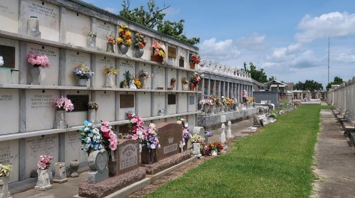

James J. Morton passed away on Monday, March 1, 2010 at East Jefferson Hospital, Metairie, LA. Son of the late Frank Morton, Sr. and Arthermise Tilquit Morton. Husband of Frances Pajeaud Morton. Father of Ty Anthony Morton, Gregory James Morton, Donna Morton Alexander and Gary Sebastian Morton. Brother of the late Clinton Morton, Sr., Frank Morton, Jr., Clarence Morton, Irvin Morton, Velma Morton, Hubert Morton, Elma Morton and Herman Morton. Grandfather of Michael Anthony Morton, Tynise Morton, Nicole Alexander Malley, Philip Alexander, and Jonathan C. Morton. Great grandfather of Caleb Morton. Also survived by a host of nieces, nephews, other relatives and friends.
Age 85 years. A native of Vacherie, Louisiana and a resident of New Orleans, Louisiana. During World War II he proudly served in the United State Navy.
Relatives and friends of the family are invited to attend the Mass of Christian Burial at Saint Peter Catholic Church, 1550 Highway 44, Reserve, Louisiana, on Saturday, March 6, 2010 at 12:30 p.m. Monsignor Robert Guse, Celebrant. Interment Saint Peter Cemetery, Reserve, Louisiana. Visitation at the above named church from 11:30 a.m. until Mass time. SERVICED BY ROBOTTOM
The Times-Picayune, New Orleans, Louisiana
March 4-5, 2010

