Jesse Franklin Moss
July 9, 1895 – June 11, 1945

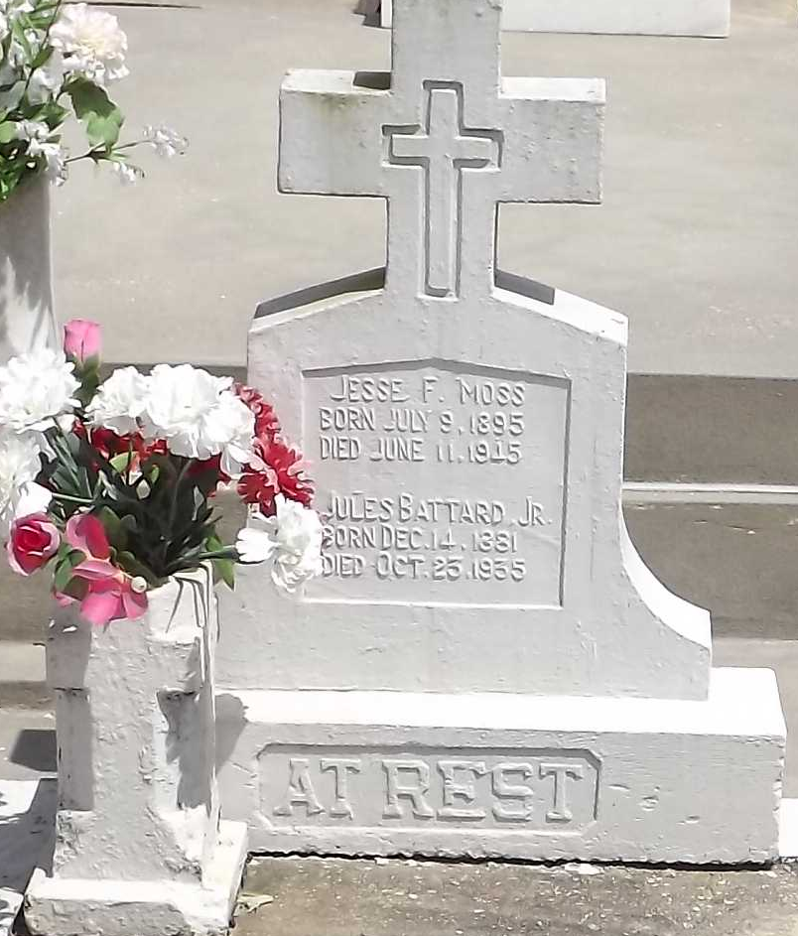
Photo by Mary Agnes Hammitt

MOSS – Of 1201 Prytania street on Monday, June 11, 1i45, at 6:15 o’clock p.m. Jesse Franklin Moss, beloved husband of Louise Battard; brother of Walter Moss of Bogalusa, La., ; aged 49 years; a native of St. Louis, Mo., and a resident of this city for 40 years.

Relatives and friends of the family, also Machinists’ Union Local No. 37 and employes of Bishop-Edell are invited to attend the funeral, which will take place from the funeral home of Joseph Laughlin Company, 4500 Magazine street on Wednesday, June 13, 1945, at 12 o’clock. Interment in Reserve, La.

Times-Picayune, New Orleans, Louisiana
Wednesday, June 13, 1945, p. 2

