Joyce (Chenier) Murry
February 23, 1939 – June 10, 2017

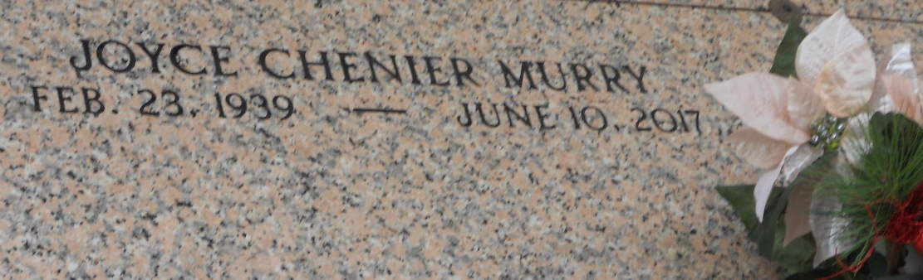
Photo by Team T-Lo

Joyce Chenier Murry passed away on Saturday, June 10, 2017. She was 78, a native of New Orleans, LA and a resident of LaPlace, LA.

Beloved wife of the late Murphy Michael Murry. Mother of Cynthia Ann Bertrand, Michael Murry, Shelia Brower, Angela Murry, Melissa Chambers and Mireille Hymel. Daughter of the late Amy Tabb and Wilford Chenier, Jr. Sister of Geraldine Weber, Barbara Bourgeois and Ricky Chenier. Also survived by grandchildren, great-grandchildren, nieces and nephews.

Relatives and friends are invited to attend the visitation at Millet-Guidry Funeral Home, 2806 W. Airline Hwy., LaPlace on Tuesday, June 13, 2017 from 6:00 p.m. to 9:00 p.m. and on Wednesday, June 14, 2017 at St. Peter Catholic Church, 1550 Hwy 44, Reserve from 9:00 a.m. to 11:00 a.m. followed by a Funeral Mass at 11:00 a.m. Interment in St. Peter Cemetery.

The New Orleans Advocate, Louisiana
Jun. 12 to Jun. 15, 2017

