Marie (Oubre) Mury
December 27, 1857 – November 19, 1942

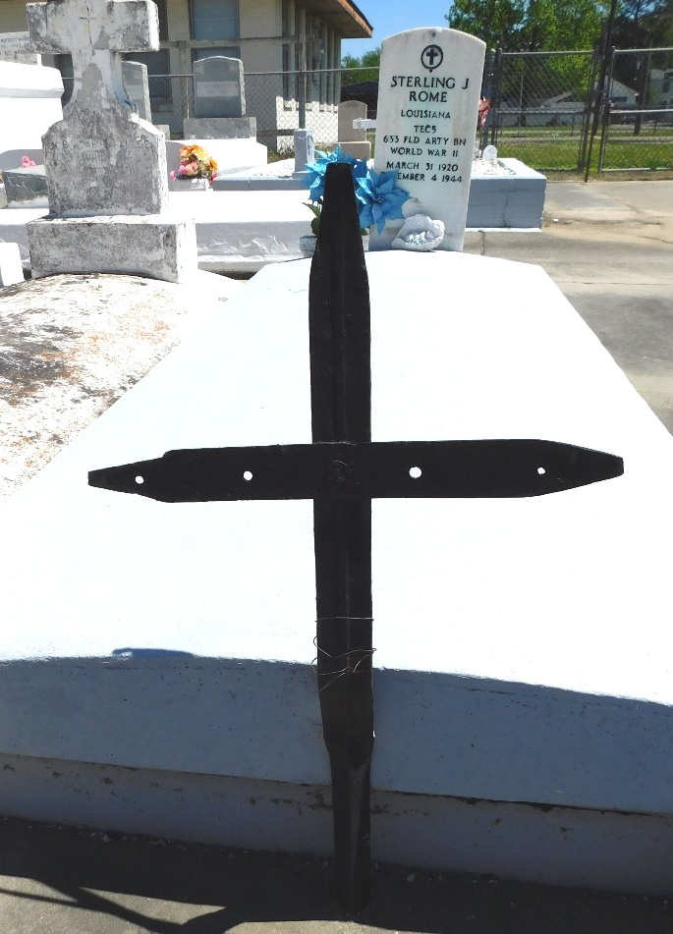
Photo by Mary Agnes Hammett
Marriage 17 Apr 1879 • Vacherie, St James, Louisiana to Victor Mury (1855 LA–1915 LA)
FROM ANCESTRY- A PICTURE OF AN IRON CROSS
MARKED Marie Oubre Mury WITH NOTATION
Gravesite. Old iron cross is marker. Buried under grandson Sterling J. Rome. Located in front of daughter, Elucia Marie Mury Rome.

