Philip Richard Mussman
July 28, 1921 – May 20, 1972

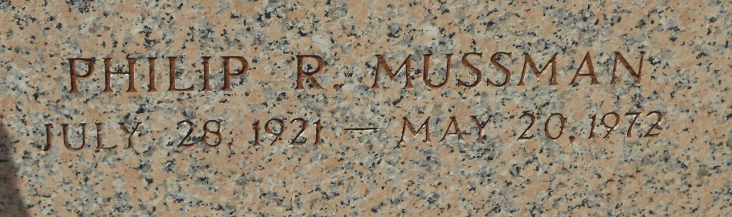
Photo by Team T-Lo
Funeral Held Tuesday for Phil Mussman

Funeral services for Philip R. Mussman, sales manager for Faucheux Chevrolet Co., Inc., were held at 10 a.m. Tuesday from the Alexander Funeral Home in Lutcher with graveside rites and interment in the St. peter Cemetery, Reserve.
Mr. Mussman died at 8:45 a.m. Saturday while driving his automobile on La. Hwy. 20 about one-half mile from his office in Gramercy. He was 50 years old.
St. James parish authorities said Mr. Mussman was driving to the post office when his car went out of control, left the highway and rolled into a ditch near the Kansas City-Southern railroad tracks. He was alone in the vehicle. Dr. A. J. Nobile, St. James Parish Coroner, said death resulted from a heart attack.
A native of Ellsworth, Minn., Mr. Mussman had been employed ty the Faucheux Chevrolet Co. for 22 years and been a resident of Gramercy for the past 20 years.
Mr. Mussman is survived by his wife, the former Elizabeth Clement of LaPlace; a son, Randall Mussman; a brother, Gage Mussman of Minnesota; three sisters, Mrs. Barbara M Smook of Arizona and Miss Shirley Mussman and Mrs. Bonnie M. Bierman of Minnesota.

L’Observateur, LaPlace, Louisiana
Thursday, May 25, 1972, p. 6

