Ludvig Sven-Olof Natell
July 27, 1949 - June 20, 2022

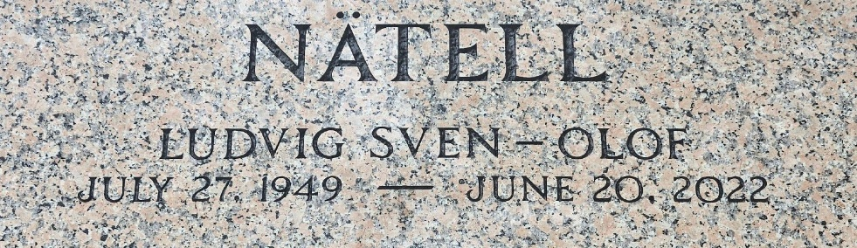
Photo by Team T-Lo
Ludvig Sven-Olof Natell passed away on Monday, June 20, 2022 at the age of 72. He was a native of Ostersund, Sweden and a resident of LaPlace, LA.
Beloved husband of 41 years to Renée Rome Natell. Loving father of Max Malmgren, Jesper Malmgren, Natalie Natell (Michael Randall) and Victoria Natell. Grandfather of Emilia Malmgren, Rita White, Theodore Malmgren and Linnéa Randall. Son of the late Sven-Erik Natell and Helny Loberg Natell. Brother of the late Anna-Britta Natell. Also survived by nieces and nephews.
At the age of 16 Sven joined the merchant marines and traveled the world as a seaman. After becoming an American citizen, he supported his family by becoming a licensed captain and operating a tow boat on the Mississippi River for most of his career. Outside of work, he kept himself busy by working with his hands. He was occupied with woodworking, camping, the outdoors, and sailing. He never lost his love of the sea. He was also an avid reader who could be found surrounded by books. He had a passion for the old ways. He never stopped learning new skills, being a current member of the LAMA blacksmithing club and Jefferson Amateur Radio Club, Inc.
Relatives and friends are invited to attend the Visitation and Funeral Service at Millet-Guidry Funeral Home, 2806 W. Airline Hwy., LaPlace on Friday, June 24, 2022. Visitation from 9:00 a.m. to 11:00 a.m. followed by a Funeral Service at 11:00 a.m. Interment in St. Peter Cemetery, Reserve, LA.
Millet-Guidry Funeral Home, LaPlace, Louisiana
June 23, 2022

