Anna (Sagona) Navarra
August 12, 1890 – June 21, 1968

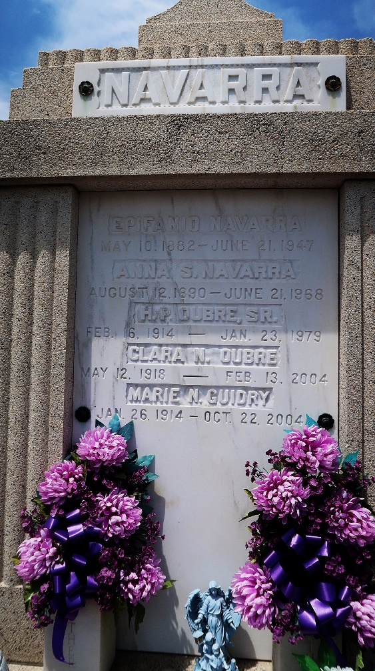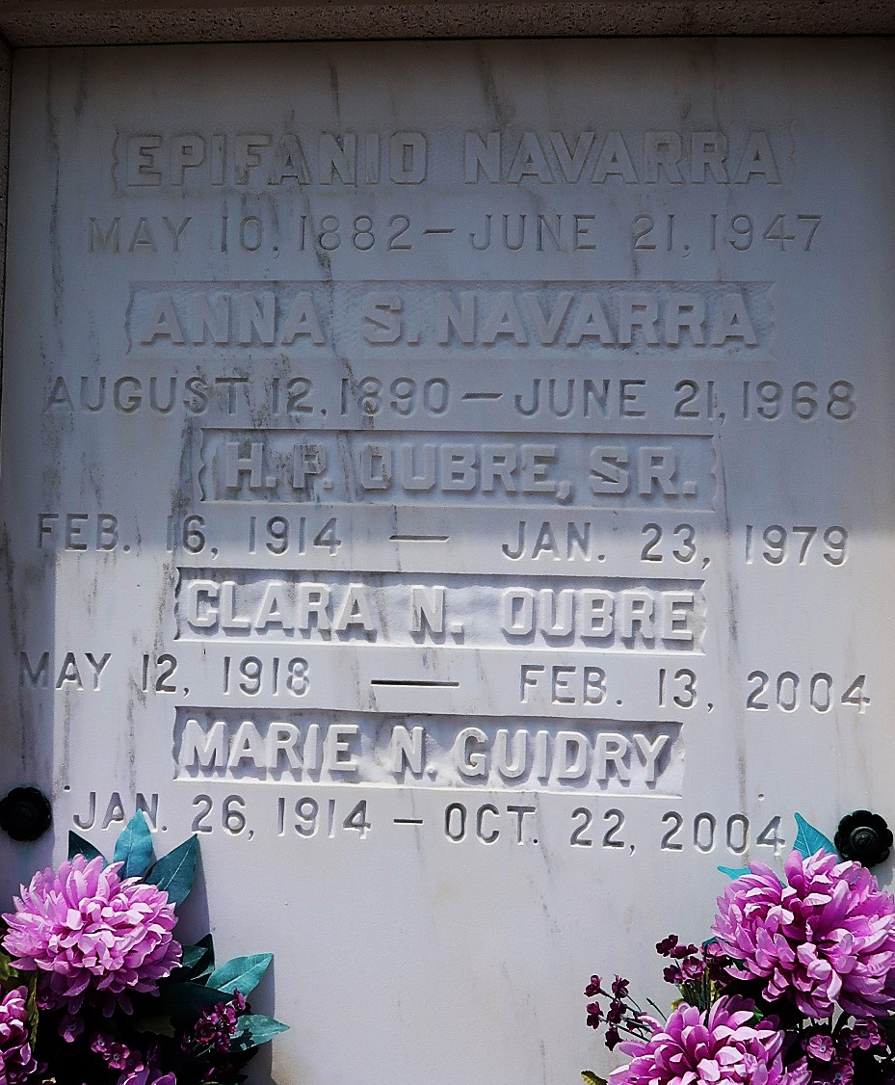
Anna Sagona Navarra died at St James Hospital, Lutcher, LA, on Friday, 21 Jun 1968 at 6:10 o'clock a.m.
She was the wife of the late Eplfano Navarro and the mother of Mrs. Wilkin Guidry, Mrs. Vita Monica, Mrs. Richard Oubre and Mrs. LeRoy Falgoust of Garyville, LA, and Mrs. Hubert Oubre of Gramercy, LA. She was the sister of Vita Sagona of Garyville, Mrs. Richard Carpenter of Pearlington, Mississippi, Louis and Frank Sagona of New Orleans and the late Fano, Salvadore, Catherine and Mamie Sagona. She was the daughter of the late Salvador Sagona and Vita Billa. Also survived by 28 grandchildren and 23 great grandchildren. Age 77 years, a native of Kansas City, Missouri, and a resident of Garyville.
Relatives and friends of the family are invited to attend the funeral services from Millet Funeral Home, Reserve, Louisiana, on Monday 24 Jun 1968 with religious services at St Hubert Church, Garyville. Interment in St Peter Cemetery, Reserve.
The Times-Picayune, New Orleans, Louisiana
22 Jun 1968, p. 18

