Carolyn Ann (Savell) Nazar
April 21, 1942 – June 8, 2015

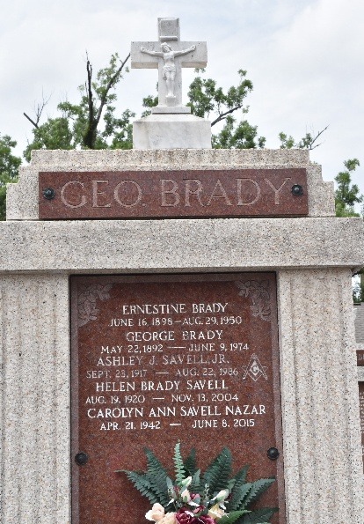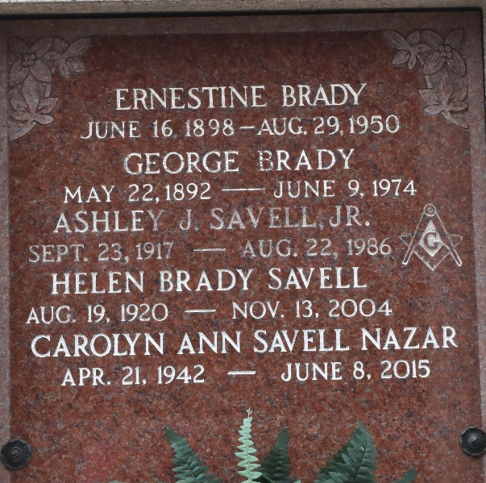

Carolyn Ann Savell Nazar passed away on Monday, June 8, 2015 at the age of 73 after a lengthy illness and is finally home in Heaven with her parents.
A native of Garyville, LA, Mrs. Nazar had resided in Arabi, Meraux, Niagara Falls, NY and most recently St. Francisville, LA. She is preceded in death by her parents, Ashley J. and Helen Savell. She was the beloved mother of Michele, Michael (Gretchen) and William Nazar (Janine). She is also survived by her siblings, Judy S. Kehoe (the late Michael), Lorraine Lottinger (Frank) and Ronald Savell (Diane). Also survived by her grandchildren, Corey Lopez, Peyton, Jackson, Britain and Mary Helen Nazar. Mrs. Nazar had a host of nieces, nephews, grandnieces and grandnephews.
She will be laid to rest with her loving parents in Reserve, LA. Funeral Mass at St. Peter Catholic Church, 1550 Hwy 44, Reserve, LA, Interment to follow in St. Peter Cemetery.
In lieu of flowers, donations can be made in her memory to the St. Tammany Humane Society, 20384 Harrison Ave., Covington, LA 70433.
Millet-Guidry Funeral Home, LaPlace, Louisiana

