Janetta (Alexis) Nelson
January 14, 1935 – May 13, 2019

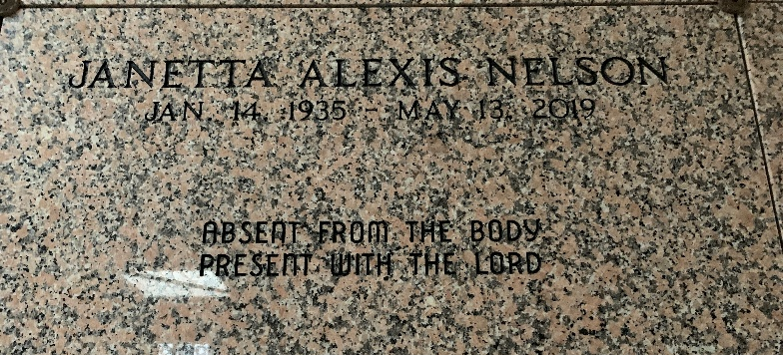
Photo by Team T-Lo
On May 13, 2019, Janetta Alexis Nelson entered her eternal at the age of 84. She was born January 14, 1935 to the union of Rayfield Alexis, Sr., and Rebecca Nicholas Alexis and was the baby of 13 children. Janetta was born and raised in Mt. Airy, Louisiana. She was affectionately known to most as Gee.
Janetta was a strong Christian in her faith. She attended St. Mark Baptist Church faithfully until her health wouldn't permit her to attend and a member of the choir. She graduated from Southern University of Baton Rouge, LA. Janetta was an educator in St. John the Baptist School System for over 30 years.
She was united in holy matrimony to Marcel Nelson, Sr. To this union two children were born: Pastor Oscar R. Nelson, Sr. and Pastor Marc A. Nelson, Sr. Janetta leaves to her loving and devoted family to honor and cherish her memories: two sons, Pastor Oscar R. (Kenyatie) Nelson, Sr. and Pastor Marc A. (Lynelle) Nelson, Sr. of Gramercy, LA.; 8 grandchildren: Devon Nelson, Allentrice Nelson, Ashontae Nelson (Antione) Fisher, Alexis Nelson, Sgt. Marc A. (Keyon) Nelson, Jr., Oscar Nelson, Jr., Joi Nelson and Shawntell Stockman. 7 great-grandchildren, one sister-in-law, Willie Mae Alexis and a host of nieces, nephew, family and friends.
She was preceded in death by her husband, Marcel Nelson, Sr., father, Rayfield Alexis, Sr., mother, Rebecca Nicholas Alexis; 9 brothers, George (Rebecca) Alexis, Sr., Rayfield (Alice) Alexis, Jr., Ernest (Lillian) Alexis, Anthony (Lydia) Alexis, Weber (Leona) Alexis, Frank (Adeline) Alexis, Sr., Major Hoover (Etherior) Alexis, Autry Alexis, Sr., Weber Alexis; 3 sisters, Odeal Alexis, Leanna Alexis Baloney and Maryland Alexis Eugene, mother-in-law, Leana Duhe Nelson, father-in-law, Estanio Nelson.
Members of Greater Woodville Baptist Church, St. Mark Baptist Church, Mt. Olive Baptist Church and all neighboring churches, faculty and staff of Garyville/Mt. Airy Magnet, West St. John High School, St. John Parish School System, St. John Assessor's Office, family and friends are invited to attend the funeral service Saturday, May 18, 2019 for 10:00 a.m. at St. Mark Baptist Church, 132 Marques Street, Mt. Airy, LA, Pastor Oscar R. Nelson, Sr. officiating with viewing at 8:00 a.m. until service time. There will also be a viewing Friday, May 17, 2019 for 4:00 – 7:00 p.m. at Bardell's Mortuary. Interment will be at St. Peter Cemetery, Reserve, LA. Her final care has been entrusted to Bardell's Mortuary, 3856 Highway 44, Mt. Airy, LA.

The New Orleans Advocate, Louisiana
May 16 to May 18, 2019

