Ethelene Nicholson
January 21, 1942 – August 17, 2023

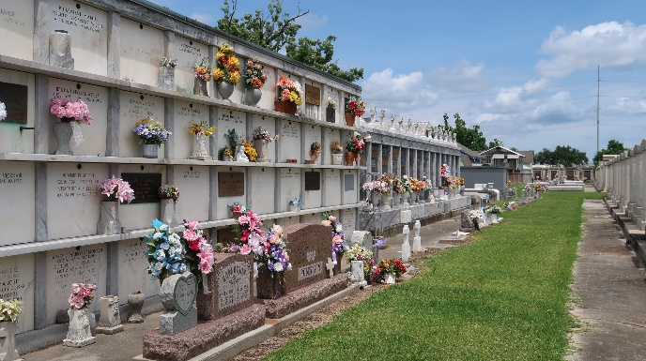
He that dwelleth in the secret place of the most High shall abide under the shadow of the Almighty. Psalm 91
On August 17, 2023 a bright shining star ceased to shine. Surrounded by her sisters and caregiver, Ethelene went home to be with the father.
Ethelene Nicholson was born on January 21, 1942. She was the first of six children born to Lucy Alexander Nicholson and Austin Nicholson.
As a meek and humble person Ethelene exemplified Ephesians 4:32-Be kind to one another, tender hearted, forgiving one another, as God in Christ forgave you. She accepted Christ later in life but always lived a life of service. She was a native of Reserve, LA and a resident of Gonzales, LA.
Ethelene was a product of the St. John the Baptist Public School System. She was a graduate of Fifth Ward High School, Class of 1961. She was also a graduate of Capital Area Vocational Business School in Baton Rouge, LA. While attending Business School she procured a job as a cashier at the school. After graduating in 1963 she was hired as the secretary at the Fifth Ward High School by Mrs. L. Richard. She worked as a secretary for 50 years in the St. John the Baptist Parish School System.
Ethelene is preceded in death by her parents Lucy and Austin Nicholson, her brother Warren Nicholson, Nieces Radiena Mason and O-Leya Marie Williams and great nephew Rayquan Mason
She will be missed by her brothers Rodney Nicholson and Ervin Nicholson; Her sisters Augustin N. Dorris and Lillian Nicholson, nephews and nieces Raydell Mason, Sr. and Taquana Masson, Kwanza Jones Williams, and Morris Williams, III, Ronique Hutchinson and Quinnell Jones, Sr., also a host of Great nieces and nephews, other relatives, and friends.
Relatives and friends of the family, Pastors, Officers and Member of Bethlehem Missionary Baptist Church and all neighboring Churches are invited to attend the Funeral Service at 12 O'clock noon, on Saturday, August 26, 2023 at Bethlehem Missionary Baptist Church, 146 E. 20th Street, Reserve, LA 70084. Visitation 10:00am until time of service at the above-named church. Entombment St. Peters Catholic Church Cemetery, LA-44, Reserve, LA 70084

Obituary published on Legacy.com by Patrick H. Sanders Funeral Home & Funeral Directors, Inc. - LaPlace on Aug. 23, 2023

