Myrtle Ann (Mizell) Nicholson
July 18, 1940 – February 12, 2004

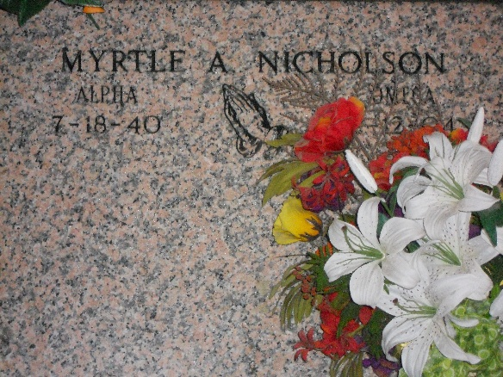
Photo by Team T-Lo
Myrtle Ann Nicholson departed this life on Thursday, February 12, 2004 at River Parishes Hospital, Laplace, La.
Daughter of the late Conelly and Celeste Jackson Mizell. Wife of the late Roy Nicholson, Sr. Mother of Tammy Robertson, Albert and Timothy Nicholson of Reserve, La., Roy, Jr., Lisa and Melissa Nicholson Of Laplace, La. And Louise Nicholson Of St. Rose, La. Sister Of Fannie C. And Harrison Mizell Of Laplace, La. And The Late Conelly, Ronald, Percy, George And Gerald Mizell. Also Survived By 20 Grandchildren, 8 Great Grandchildren, Daugh-ters And Son-In-Law. A Devoted Godchild Ana Alicia Frank, A Host Of Nieces, Nephews, Cousins And Friends. A Native And Resident Of Reserve, La., 63.
Relatives And Friends Of The Family, Pastor, Officers And Members Of Milesville Memorial Church Of God In Christ, Bethlehem Baptist Church, New Wine Christian Fellowship And All Neighboring Churches, St. Charles And St. John Sheriff Office Are Invited To Attend The Funeral Services On Tuesday, February 17, 2004 At 10:00 A.M. At The New Wine Christian Fellowship, 1929 West Airline Hwy, Laplace, La. Bishop Ronad Frank, Pastor Offic. Rev. Neil Bernard Host Pastor. Visitation At The Church Tuesday From 9:00 A.M. Until Funeral Time. Services Entrusted To Hobson Brown Funeral Home
Times Picayune, New Orleans, Louisiana
February 16, 2004

