John Joseph Ockman
December 25, 1941 – November 5, 2003

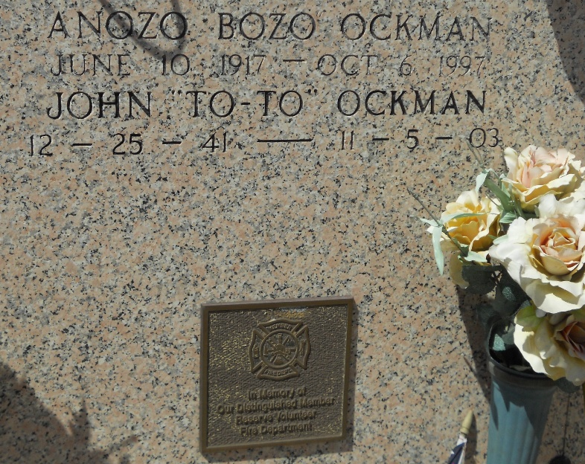
Photo by Team T-Lo

John J. ''To-To'' Ockman on Wednesday, November 5, 2003 at 2:56 pm. Beloved son of the late Anozo and Anna Ockman. Brother of Carolyn O. Zoerner. Uncle of Tonya Chatman. Great Uncle of Desiree' and Whitney Chatman. Step-Uncle of Albinus, Andrew, Michael and Ronald Zoerner. Brother-in-law of Albinus E. Zoerner, Jr.
Former employee of Port of South Louisiana Harbor Commission and lifelong member of the Reserve Volunteer Fire Department. Age 61 years. A native and lifelong resident of Reserve, Louisiana.
Relatives and friends of the family are invited to attend services. Visitation at Millet-Guidry Funeral Home, 2806 West Airline Highway, LaPlace, Louisiana on Saturday, November 8, 2003 from 8:30 am until 10:00 am followed by religious services in the funeral home chapel at 10:00 am. Burial in St. Peter Church Cemetery, Reserve, La.

The Times-Picayune, New Orleans, Louisiana
Nov. 8, 2003.

