Leo J. Ockman
December 26, 1951 – February 16, 2008

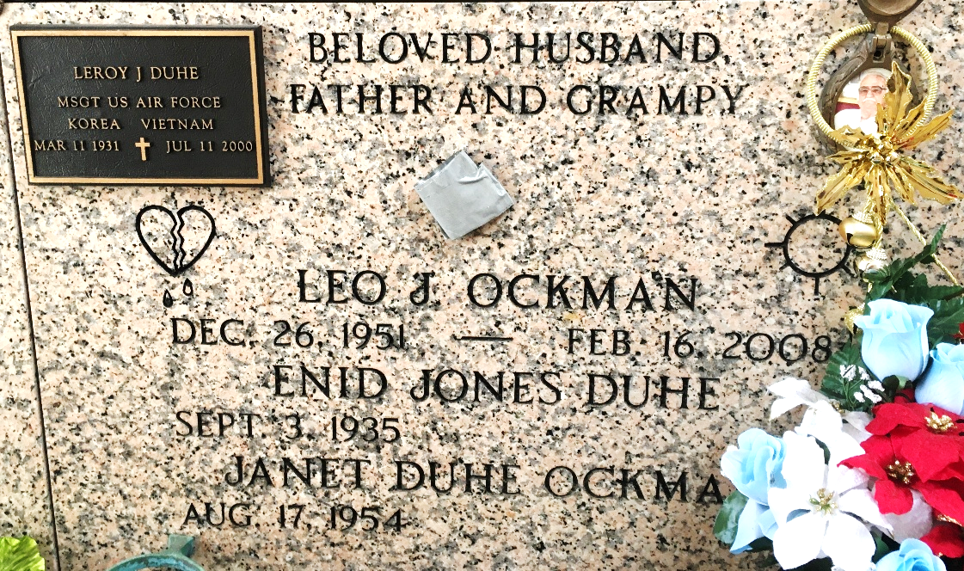
Photo by Team T-Lo

Leo Ockman on Saturday, February 16, 2008 at 11AM. Beloved husband of Janet Duhe Ockman. Father of Tammy Ockman Rodrigue and Jessica Ockman. Grandfather of Kayley Naquin and Harlie Rodrigue. Son of the late Luse and Lydie Ockman. Son-in-law of Enid Duhe. Brother of Leroy, Michael and Danny Duhe, Terry Howell, Coye Howell, Karen, Betty and Anna Duhe. Nephew of Edith Boudreaux. Age 56 years, a native of Reserve and a resident of LaPlace for the past 25 years.
Relatives and friends are invited to attend services. Visitation at Ascension of Our Lord Church, 1809 Greenwood, LaPlace, La., on Tuesday, February 19, 2008 from 10AM to 12PM. Followed by Religious Services at the church at 12PM. Burial in St. Peter Cemetery, Reserve, La. Arrangements by Millet-Guidry Funeral Home, LaPlace, La.

The Times-Picayune, New Orleans, Louisiana
Feb. 18, 2008

