Marie Doris (Berthelot) Ockman
April 13, 1935 – March 4, 1996

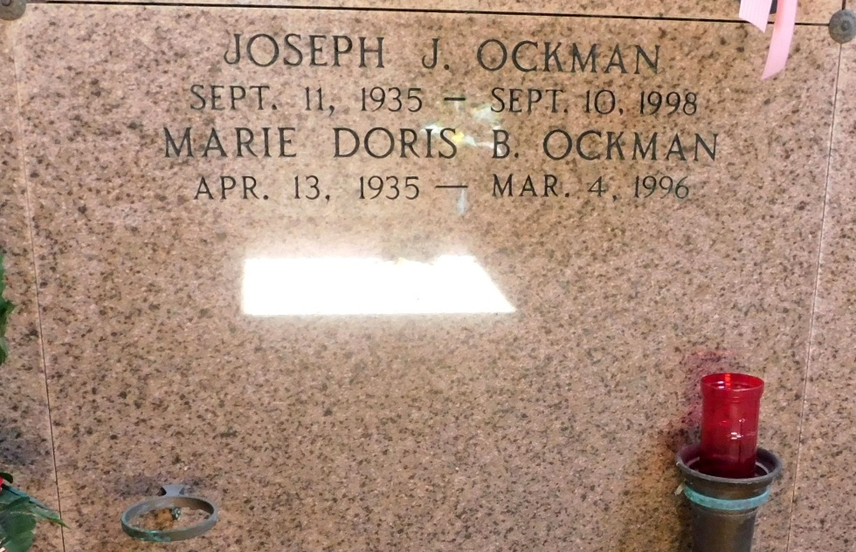
Photo by Mary Agnes Hammett

Ockman, Marie Doris Berthelot

A resident of Reserve, she died at 12;25 p.m. Monday, March 4, 1996. She was 60 and a native of LaPlace.
Visiting at Millet-Guidry Funeral home, 2806 W. Airline Highway, LaPlace, 5 to 10 p.m. Tuesday and 10 a.m. until religious services in the chapel at noon Wednesday. Burial in St. Peter Cemetery, Reserve.
Survived by husband, Joseph Ockman; a son, Brian Ockman; three daughters, Debra McBrayer, Connie Allbritton and Pamela Kinsey; mother, Noemie Berthelot; a sister, Inez St. Germain; and 12 grandchildren. Preceded in death by father, Norbert Berthelot.

The Advocate, Baton Rouge, Louisiana
Tuesday, March 5, 1996, p. 8-A

