Claude L. Ocmand Sr
January 7, 1922 – May 6, 2001

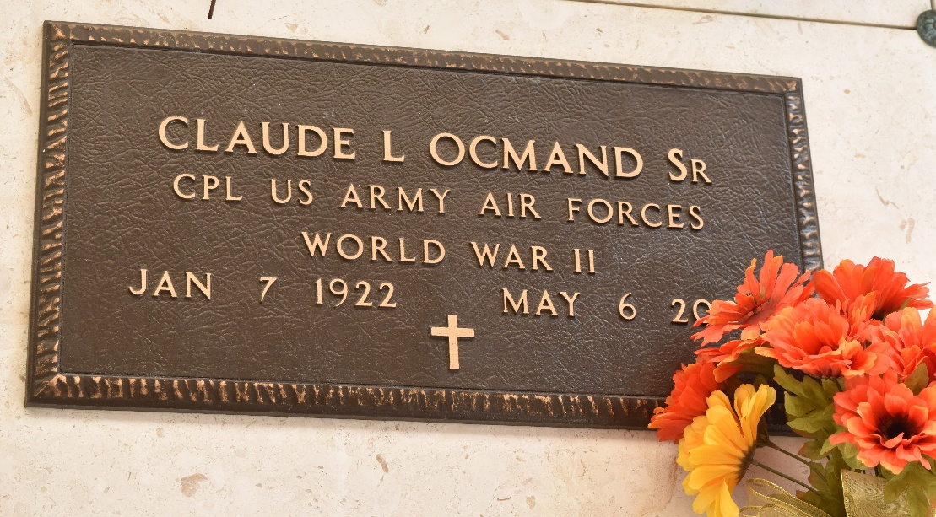

OCMAND LAPLACE – Claude L. Ocmand Sr., 79, a native of Garyville and resident of Reserve for 54 years, died May 6. He was the husband of Bernadette K. Ocmand and father of Tama Forsyth, Lisa Brasington and David, Claude Jr., Chris Sr., Stephen, Joel Sr., Kirk, Cory and Jeffrey Ocmand.
He was also the son of the late Antoine and Marie Tamplain Ocmand and brother of Myrna Cox, Gillespie Sr. and Wilbert Ocmand and the late Alice Waguespack and Onell and Antoine Ocmand. He is also survived by 25 grandchildren and eight great-grandchildren.
Services were May 8 at St. Peter Catholic Church, Reserve, with interment at the church cemetery.

L’Observateur, LaPlace, Louisiana
Wednesday, May 9, 2001

