Gillespie Adam Ocmand, Sr.
January 15, 1933 - December 29, 2023

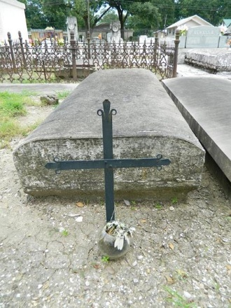

Gillespie Adam Ocmand, Sr. A resident of Mt. Airy, passed away on Friday December 29, 2023 at the age of 90 years old.
Beloved husband of Elaine Ocmand for 68 years. Loving father Gillespie Ocmand, Jr. (Cynthia), Elizabeth Deroche (Blane), Deborah Ocmand, Mark Ocmand (Shannon), Annette Simmons (Wayne), and the late Katherine Ocmand. Grandfather of Jenny Ocmand, Krista James (Barry), Brandy Hollingsworth, Nancy Lyons (Landon), Matthew Deroche (Ginger), Lauren Harris (Nick), Holly Keller (Casey), Brittany Abadie (Josh), Katherine Marse (Dylan), Travis Simmons (Katie), and Heather Loftin (Mike). Great-grand-father of 26 and Great-great Grandfather of 1.
Son of the late Antoine Ocmand and Marie Tamplain Ocmand. Brother of Myrna Cox (the late Donald), and the late Claude Ocmand (the late Bernadette), O’Neil Ocmand (the late Louise), Wilbert Ocmand, Sr. (the late Theresa), Alice Waguespack (the late Ellis). Survived by numerous nieces, nephews, and cousins.
Relatives and friends are invited to attend the Visitation and Funeral Mass at St. Hubert Catholic Church, 176 Anthony F Monica St, Garyville, on Thursday, January 4, 2024. Visitation at the church from 9:00 a.m. to 11:00 a.m. followed by a Funeral Mass at 11:00 a.m. Interment in St. Peter Cemetery, Reserve, LA.

Rose Lynn Funeral Home, Lutcher, Louisiana

