Dolly (Boudreaux) Ocmond
February 21, 1949 - May 14, 2023

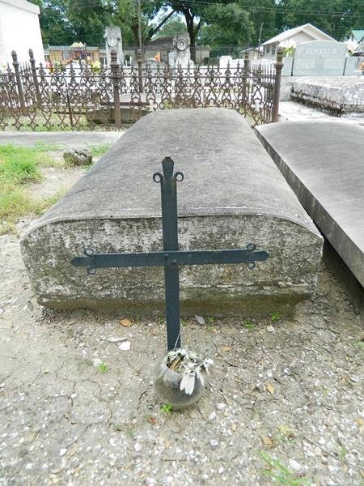

Dolly Boudreaux Ocmond, a native and resident of LaPlace, LA passed away on Sunday, May 14, 2023 at the age of 74. Affectionately known as Maw-Maw Dolly by many, she babysat for almost 35 years and was recently forced to “retire” not by choice. Prior to loving all of her “grandchildren”, she worked for and retired from the St. John the Baptist Parish School System as a bookkeeper. In the early 1970’s she started and ran the St. Joan of Arc Sunday school program. Dolly never met a stranger and eagerly shared stories of years gone by. She especially looked forward to her luncheons and outings with her Pokeno group, and her Leon Godcheaux Class of 1967 group.
She was the beloved wife of Wilbert J. Ocmond, Jr. for over 53 years. She is also survived by one son, Brandon (Christie); one daughter Raina; 3 grandchildren, Paige (Taylor) Durocher, Ethan (Sommer) Ocmond and Aiden Ocmond; 5 great grandchildren, Camille, Cameron, Ty, Rorie, and Kate; brothers and sisters-in-law, Brent (Karen) Ocmond, Nathan (Joan) Ocmond, Marsha (the late Kim) Martin and Nancy Ocmond; and numerous nieces and nephews.
She was preceded in death by her parents, Sylvain and Evna Duhe Boudreaux; mother and father-in-law, Wilbert Sr. and Therese Oubre Ocmond; and one sister, Penny (Harry) Ancale.
Relatives and friends are invited to attend the Visitation and Funeral Mass at St. Joan of Arc Catholic Church, 529 W. 5th St., LaPlace, LA on Friday, May 19, 2023. Visitation will be held at the church from 10:00 a.m. to 1:00 p.m. followed by a Funeral Mass at 1:00 p.m. Interment in St. Peter Catholic Church Cemetery, Reserve, LA at a later date.
In lieu of flowers, masses are preferred.

Rose Lynn Funeral Home, Lutcher, Louisiana
May15, 2023

