Therese (Oubre) Ocmond
January 22, 1928 – January 15, 2013

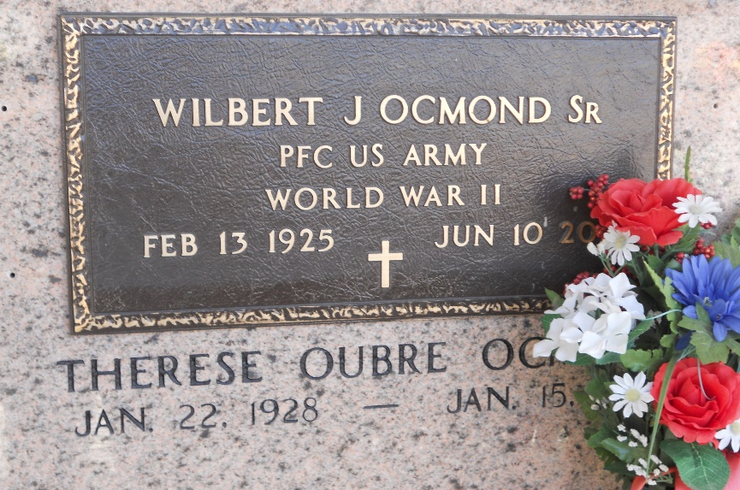
Photo by Team T-Lo

Therese Oubre Ocmond was born in Garyville on January 22, 1928. She passed away at age 84, on January 15, 2013.
She is survived by her husband of 64 years, Wilbert J. Ocmond, Sr, and her children, Wilbert Jr (Dolly), Nathan (Joan), Brent (Karen), Marsha Martin (Kim "Soupy"), and Nancy Ocmond. Mrs. Ocmond was preceded in death by her parents, August and Emilie LeBouef Oubre, her siblings, Melvin, Calvin, August, Raymond, Joseph (Gayle) and Leroy Oubre, Eunice Oubre LeBeau and one great grandchild, Christopher House.
She is survived by her brother, George Oubre (Mary Ann) and her sister, Mary Rita Berthelot. Grandmother to Brandon (Christie), Raina Ocmond, Brandilynn (Bryan) Robichaux, Heidi House, Jonathan, Shaun, Ian (Carla), Joshua, Troy, Elicia, Marcus, Jeremy, Cullen (Andi), Scott (Rachel), Robbie (Katie) Ocmond, Ryan (Emily) Martin and Mindy Kuhn (Jim). Great-grandmother to Paige, Ethan, Aiden Ocmond, Joseph and Ariel Robichaux, Blaise House, Lucus, Camilla, Ian, Elijah, Alexander, Patrick, Gaby, Sophia Ocmond and Julia Martin.
Mrs. Ocmond was a volunteer for Food for Families for the Archdiocese of New Orleans and a CCD teacher for St. Hubert until the time of her death. She was an active member of the St. Joan of Arc Catholic Church KCA and the St. Hubert Ladies Altar Society.
Mrs. Ocmond donated her body to Tulane Medical School. A Memorial Mass will be held on Saturday, January 19, 2013 at 11:00 a.m. at St. Hubert's Catholic Church in Garyville, La. A burial will follow at a later date. In lieu of flowers, Mass intentions are preferred. The family would like to thank St. James Hospital and the River Region Hospice for the gentle care given to Mrs. Ocmond.
TheAdvocate.com
Jan. 16 to Jan. 19, 2013

