Wilbert J. Ocmond, Sr.
February 13, 1925 – June 10, 2013

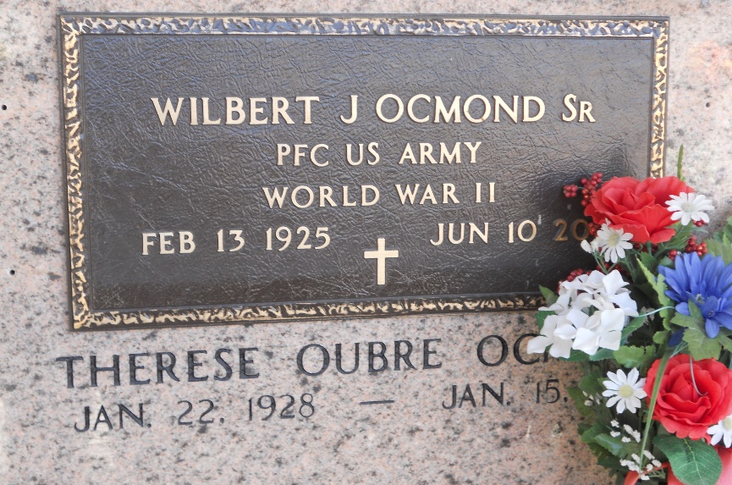
Photo by Team T-Lo

Wilbert J. Ocmond, Sr. passed away on Monday, June 10, 2013.
Beloved husband of the late Therese Oubre Ocmond. Father of Wilbert Ocmond Jr. (Dolly), Nathan Ocmond (Joan), Brent Ocmond (Karen), Marsha Martin (The late Kim) and Nancy Ocmond. Grandfather of Brandon, Raina, Dr. Cullen, Scott, Robbie, Jonathan, Shaun, Ian, Joshua, Marcus, Elisha, Troy and Jeremy Ocmond, Brandilynn Robichaux, Heidi House, Ryan Martin and Mindy Kuhn. Also survived by 17 great-grandchildren.
Son of the late Antoine and Marie Tamplain Ocmond. Brother of Gillespi Ocmond, Myrna Cox and the late Alice Waguespack, Claude Ocmond, Oneil Ocmond and Antoine Ocmond Jr.
Age 88. A native and resident of Garyville, LA.
TheAdvocate.com
June 11-13, 2013

