Bertha M. Ory
October 26, 1875 – April 26, 1955

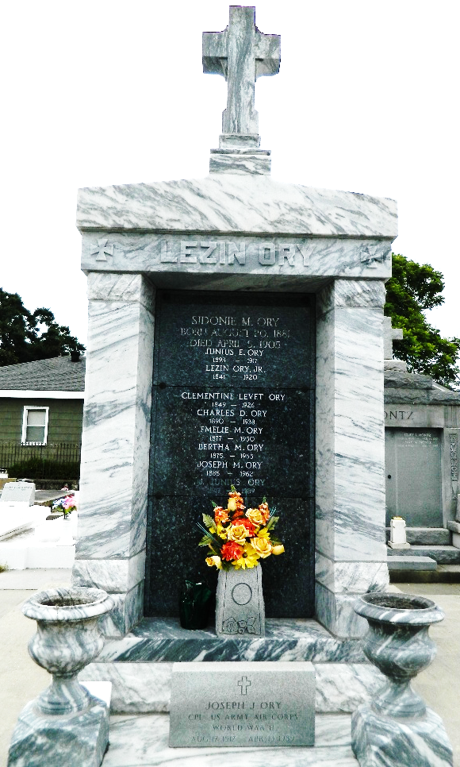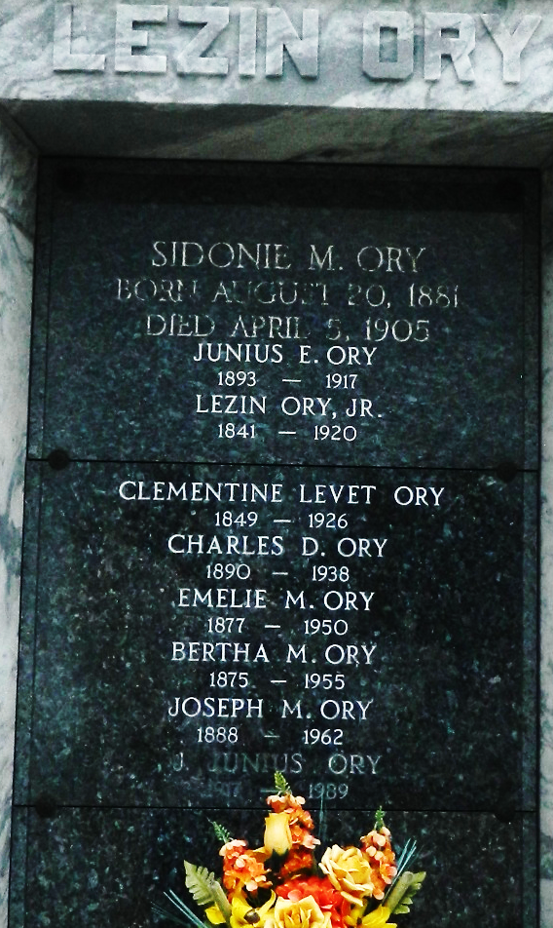

Age 79 years, a native of St John the Baptist Parish, Louisiana, and a resident of New Orleans for the past 5 years.

She was the daughter of the late Clementine Levet and Lezin Ory and sister of Mrs. Louis A. Caboche of New Orleans and Joseph M. Ory of Reserve, Louisiana.

Services were Wednesday 17 Apr 1955 at St Rose de Lima Church, New Orleans, with interment in St. Peter Cemetery, Reserve.
The Times-Picayune, New Orleans, Louisiana
April 27, 1955

