Burton John Ory
July 8, 1950 – April 25, 2023

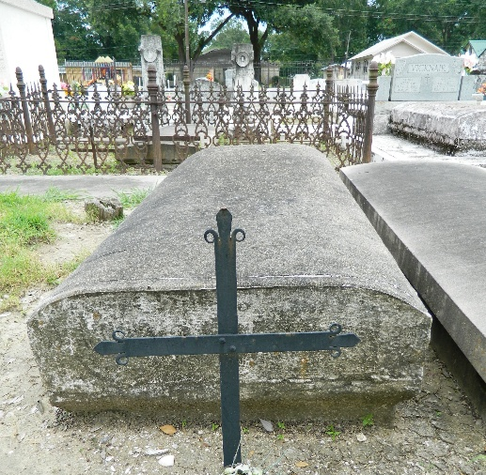
Photo by Team T-Lo

Visitation services for Burton John Ory, 72, West Plains, Mo., will be held from 6 until 8 p.m. Friday, May 5, 2023, in the Main Room at Robertson-Drago Funeral Home.
Maj. Burton John Ory was born July 8, 1950, in Reserve, La., to Raymond Ory, Sr., and Claudia Ory, and departed this life on April 25, 2023.
He is survived by his wife Carolyn Pitcock Ory; two daughters Julie Ory, Baton Rouge, La., and Melissa Ory Suarez and husband Alex, Allen, Texas; his blessing of five grandchildren; three brothers Ronald Ory and wife Linda, Brandon, Fla., Raymond Ory and wife Susan, Katy, Texas, and Rodney Ory and wife Lynn, LaPlace, La.; one sister Kathy Ory Snage and husband Alex, High Point, N.C.; and several nieces and nephews.
Burt always had a love of law enforcement. He graduated from Loyola University in New Orleans with a master's degree in criminology and began his career with an internship with the FBI. He joined the St. John Parish Sheriff's Office in 1972, where he remained until his retirement in 2004. While there he quickly worked his way up the ranks, being promoted to lieutenant, captain and major. Mr. Ory served his community for 32 years. Burt was also a veteran, having served with the United States Marines for eight years before he was honorably discharged. He was in the Marine Reserves from 1972 to 1980.
He was an avid fisherman and loved to rebuild antique and classic cars. There was always a car in his garage that he was working on. Burt also loved cooking and was frequently asked to prepare his great pots of jambalaya for local community functions. He loved sharing his cooking and if you ever visited him, you always left with something special from his freezer.
A celebration of life service will be held in Louisiana at a later date. Memorial contributions may be made to West Plains Regional Animal Shelter and may be left at or mailed to Robertson-Drago Funeral Home.

West Plains Daily Quill, West Plains, Missouri
May 3 to May 4, 2023

