Charles Didier Ory
June 2, 1890 – May 16, 1939

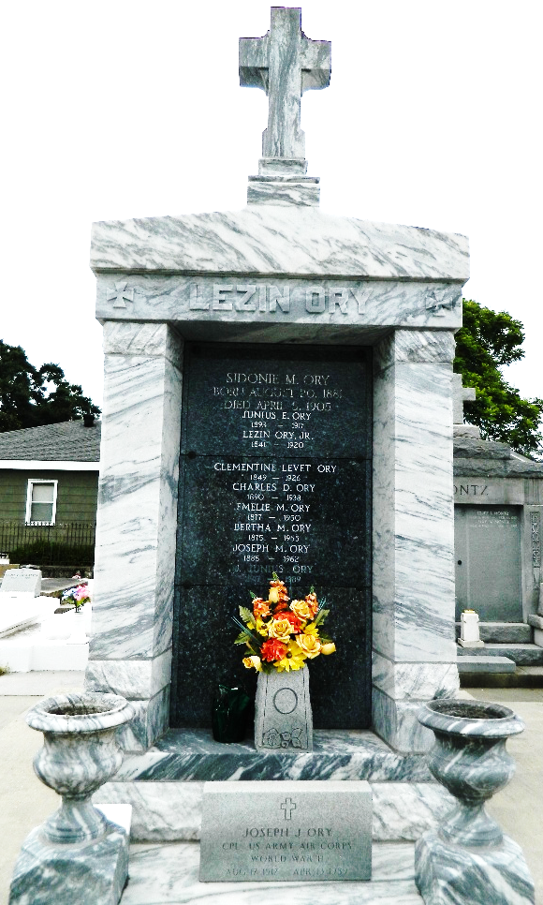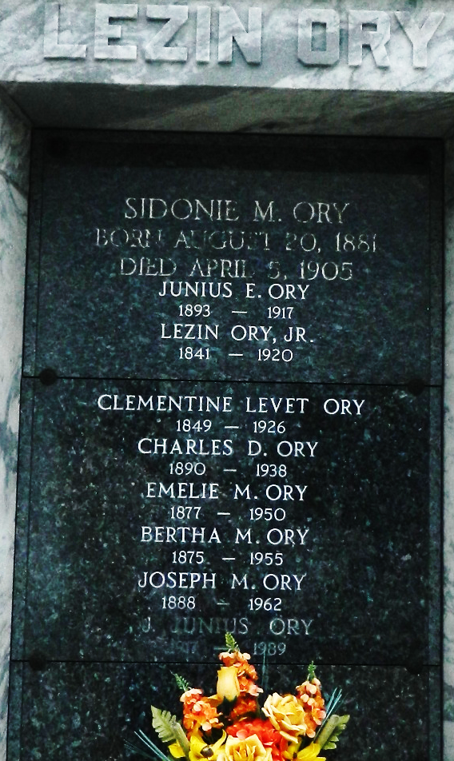

ORY - At Lyons, La, on Tuesday, May 16, 1939, CHARLES B. ORY, husband of Aline Millet, father of Helen Marie, Yvonne, Harry and John Ory, brother of Joseph, Emily, Bertha and Mrs. L. A. Caboche, aged 49 years, a native of Assumption parish and a resident of St John parish for the past 35 years.

Relatives and friends of the family are invited to attend the funeral, which will take place on Thursday, May 18, 1939, at 3 o'clock p.m., from Jules Millet funeral home, Reserve, La. Religious services at St Peter's church, Reserve, La. Interment in St Peter's cemetery, Reserve.
The Times-Picayune, New Orleans, Louisiana
18 May 1939, p 2

