Clementine (Levet) Ory
July 6, 1849 – April 9, 1926

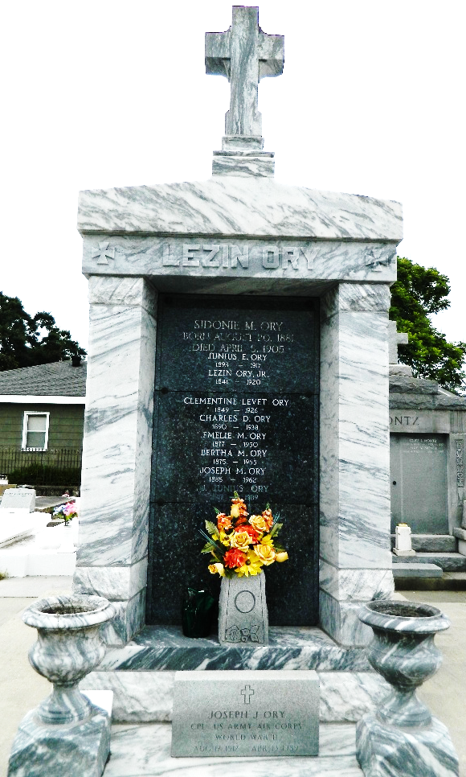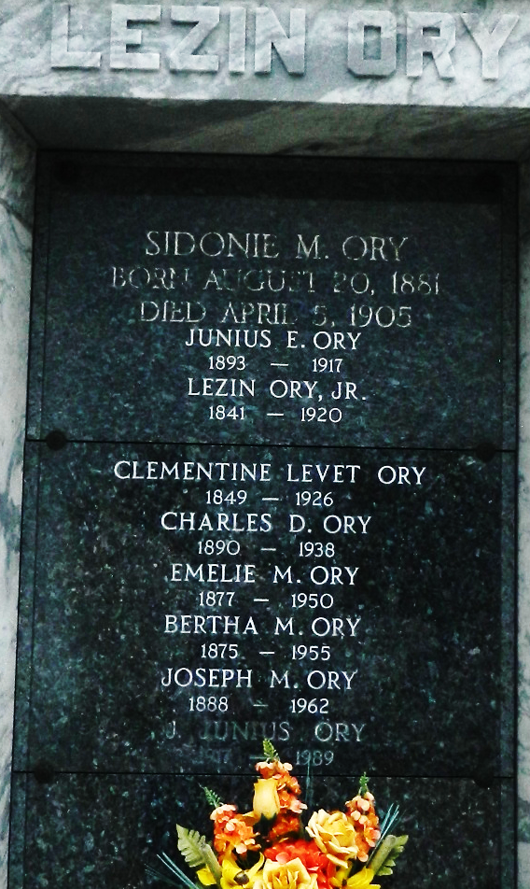

Died Friday, April 9, 1926 at 11:45 o'clock p.m., Clementine Levet, wife of the late Lezin Ory. Aged 76 years, a native of Louisiana.

The relatives and friends of the family are respectively invited to attend the funeral which will take place on Sunday, April 11, at 7 o'clock a.m. with requiem high Mass from St Peter's Catholic Church in Reserve, LA. Funeral cortege will leave the home of her son-in-law, Dr. Louis Cabouche, 1917 Esplanade Ave, at 7 a.m. Sunday. Interment in Reserve, LA, cemetery [St Peter Cemetery].
The Times-Picayune, New Orleans, Louisiana
April 11, 1926

