Cora Ory
April 30, 1893 – November 30, 1897

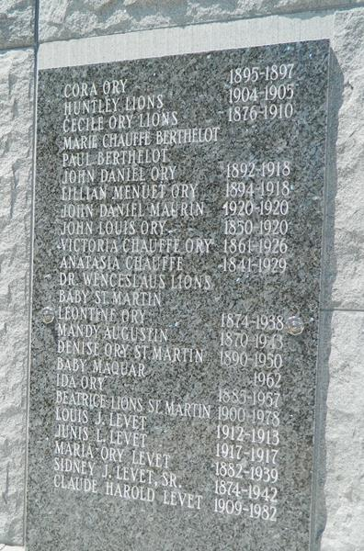

Cora was baptized at St. Peter's Church, Reserve, St. John the Baptiste Parish, Louisiana on 30 April 1893.
(St Peters Church Baptismal Vol # 4/pg 45)

She drowned on 30 November 1897.
(St. Peter's Church Funeral Book Vol 2 pg 33)

