Dorothy (Vicknair) Ory
January 9, 1928 – January 27, 2006

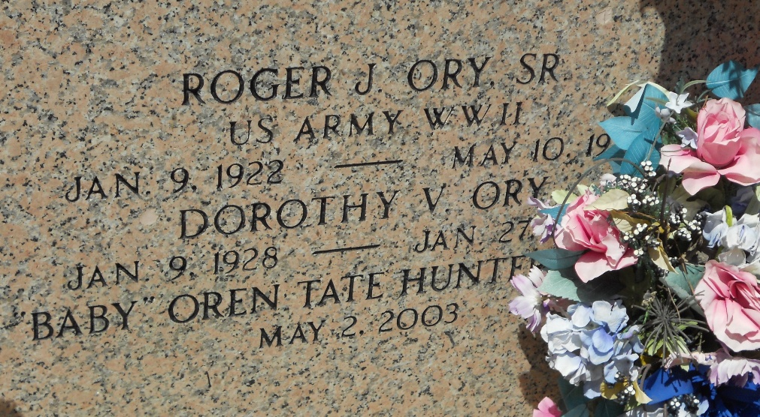
Photo by Team T-Lo

Dorothy Vicknair Ory on Friday, January 27, 2006 at 3:15 p.m. Beloved wife of the late Roger Ory Sr. Mother of Roger Ory Jr., Karen O. Wilson and Kyle Ory. Grandmother of Shawn Ory, Melissa W. Kuhn, Ranney Jr., Dane and Blake Wilson. Great-grandmother of Billy and Tabitha Kuhn.
Daughter of the late Emile Sr. and Clotilde Millet Vicknair. Sister of Harold and E.J. Vicknair Jr. and Lois Caillouet. Age 78 years. A native of and resident of Garyville, LA.
Relatives and friends of the family, also members of The Ladies Altar Society are invited to attend services. Visitation at MILLET-GUIDRY FUNERAL HOME, 2806 W. Airline Hwy., LaPlace, LA on Sunday, January 29, 2006 from 5:00 p.m. until 9:00 p.m. and on Monday from 10:00 a.m. until 11:30 a.m. Followed by Religious Services at St. Hubert Catholic Church, Garyville, LA at 12:00 noon. Burial in St. Peter Cemetery, Reserve, LA.

The Times-Picayune, New Orleans, Louisiana
Jan. 29, 2006

