Emelie M. Ory
November 22, 1877 – July 11, 1950

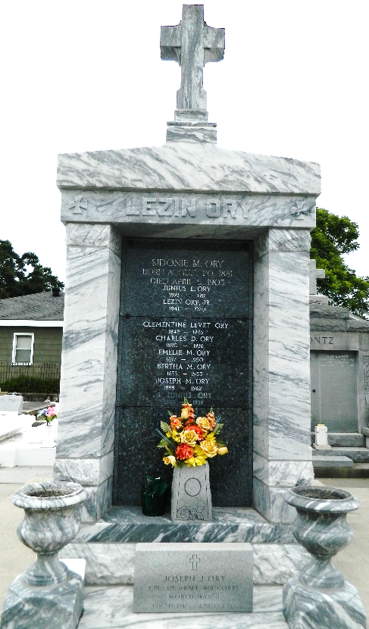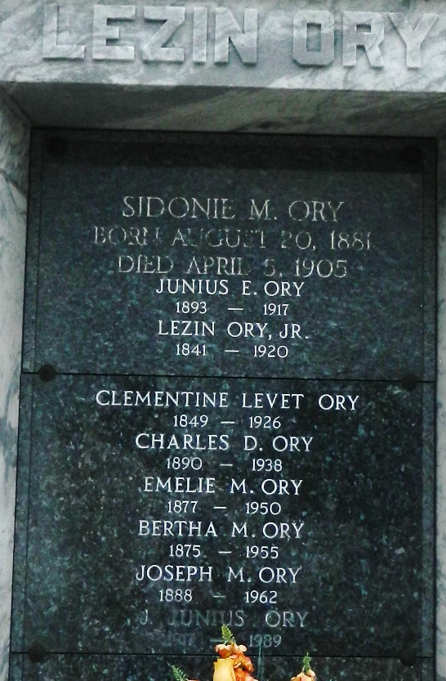

Age 72 years, a native of Assumption Parish, Louisiana, and a resident of New Orleans for the past 2 1/2 years. Daughter of the late Lezin Ory and Clementine Levet. Sister of Miss Berthe and Joseph Ory and Mrs. L. A. Caboche.

Services were Wednesday, 12 Jul 1950 at St Rose de Lima Church, New Orleans, with interment in St. Peter Cemetery, Reserve, Louisiana.

The Times-Picayune, New Orleans, Louisiana
July 12, 1950

