Emygde Ory
August 4, 1845 – November 22, 1928

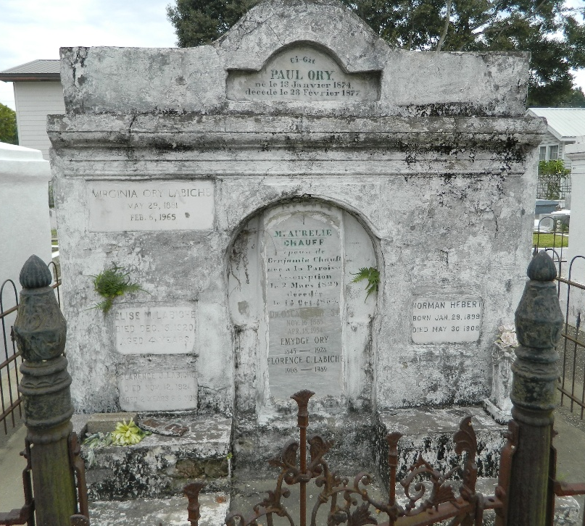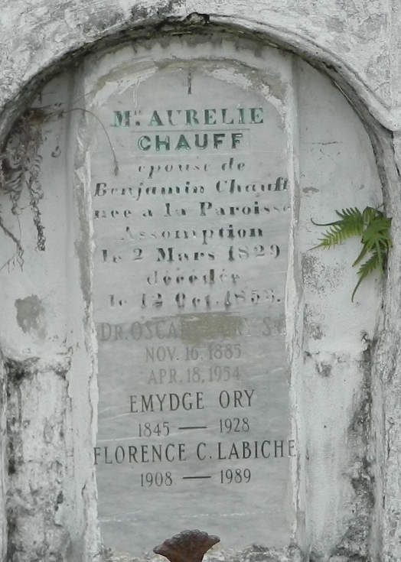

Died at Lions, Louisiana, at age 83 years. Father of Dr. Oscar J. Ory, Mrs. Emile Hebert and Mrs. Sidney Labiche. Services were Saturday, 24 Nov 1928 at St. Peter Church, Reserve, Louisiana, with interment in St. Peter Cemetery.

The Times-Picayune, New Orleans, Louisiana
November 24, 1928

