Esther (Bourgeois) Ory
July 8, 1901 – August 26, 1999

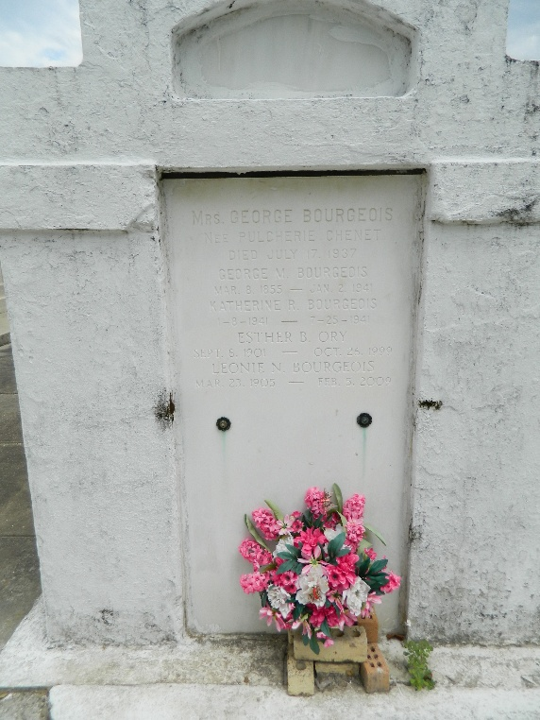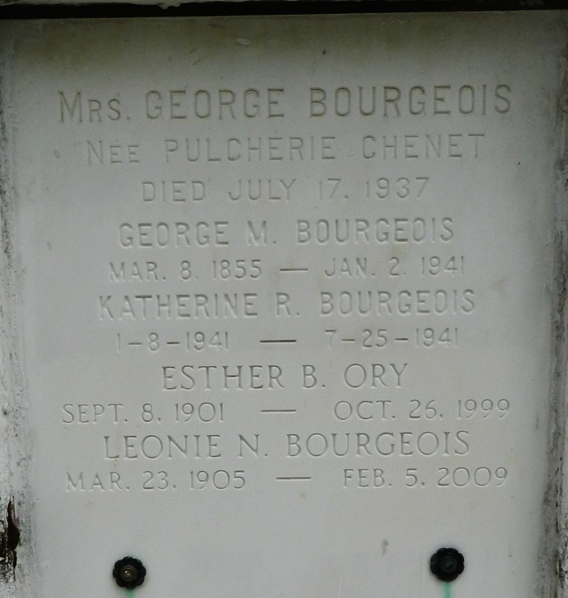

Esther Bourgeois Ory died Thursday 26 Aug 1999 at 4:45 a.m. She was the mother of George H Ory. Also survived by two grandchildren and two great grandchildren.
She was the daughter of the late George M. and Pulcherie Chenet Bourgeois and the sister of Leonie N Bourgeois. She was a native and resident of Garyville, Louisiana.
Relatives and friends of the family were invited to attend the funeral services at Millet Guidry Funeral Home, 2806 West Airline Hwy, Reserve, Louisiana on Saturday 28 Aug 1999 in the funeral home chapel with interment in St Peter Cemetery, Reserve.

The Times-Picayune, New Orleans, Louisiana
August 27, 1999

