Esther Marie (Lasseigne) Ory
August 24, 1892 – June 1, 1970

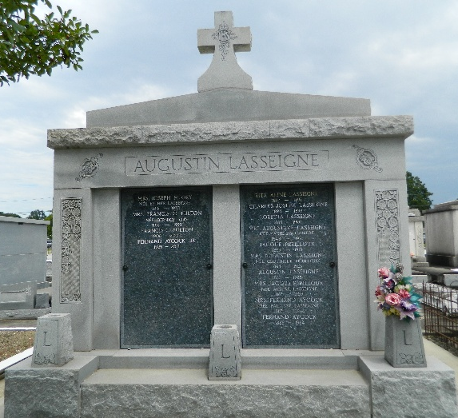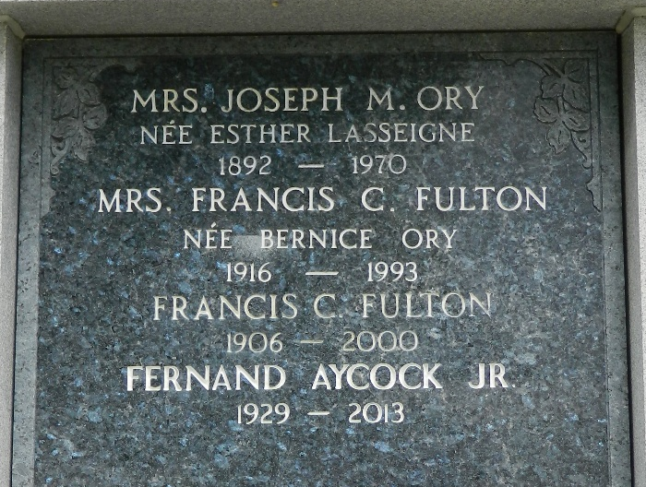

Age 77 years, a native and resident of Laplace, Louisiana, and a former resident of Reserve, Louisiana.
Wife of the late Joseph M. Ory and mother of Mrs. Francis (Bernice) Fulton and Junius Ory, both of Laplace.
Services were Wednesday 3 Jun 1970 at St. Joan of Arc Church, Laplace, with interment in St Peter Cemetery, Reserve.

The Times-Picayune, New Orleans, Louisiana
June 3, 1970

