Felicien Jean Baptiste Ory
June 24, 1843 – January 14, 1924

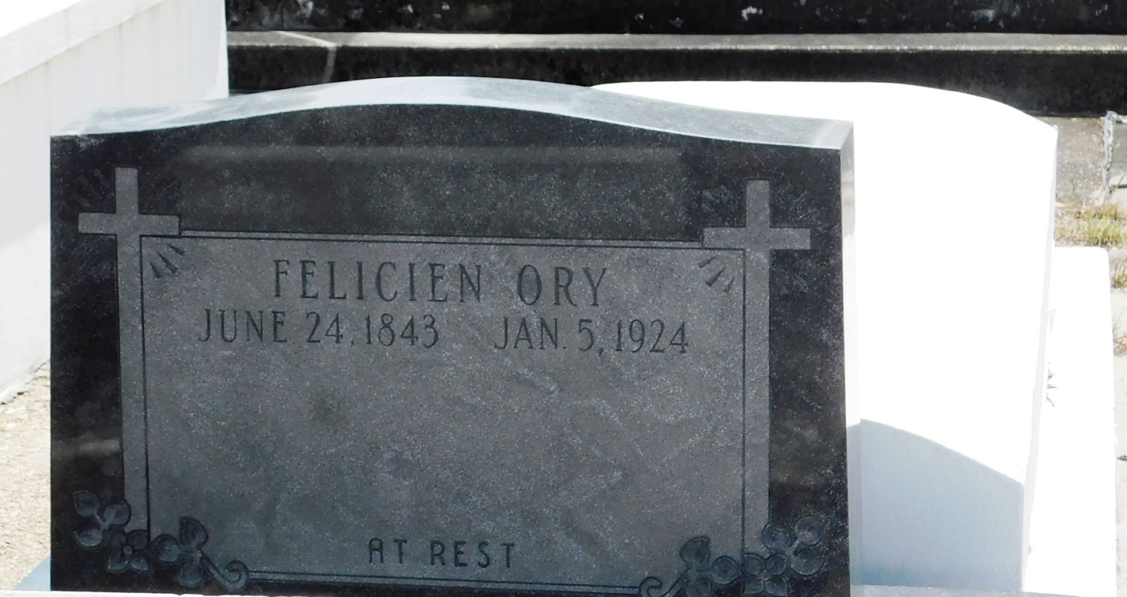
Photo by Mary Agnes Hammett

Felicien Jean Ory died Monday, 14 Jan 1924 at 5:10 p.m. at his residence in St. James Parish, Louisiana, at age 80 years, 6 months and 21 days. He was a native of Louisiana.

Services were Tuesday, 15 Jan 1924, with interment in Reserve, Louisiana.

The Times-Picayune, New Orleans, Louisiana
January 16, 1924

Note difference in death dates on tomb (1/5/1924) and in obit (1/14/1924)

