Hazel (Montegut) Ory
November 13, 1918 – November 6, 2019

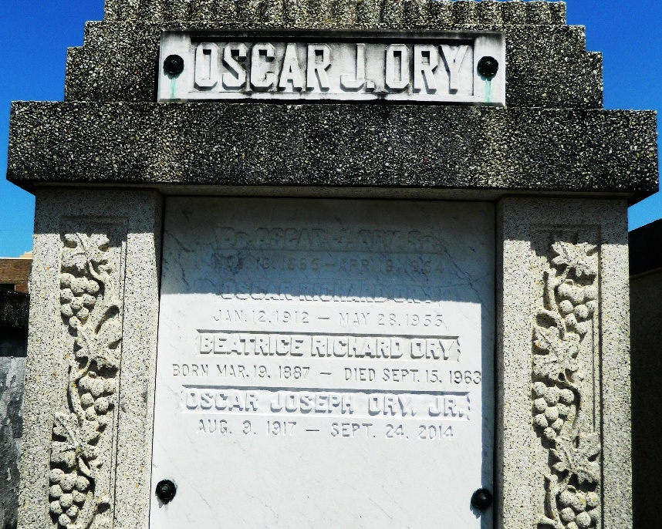
Hazel is entombed with her husband, Oscar J. Ory Jr.

Hazel Montegut Ory was born in Laplace, Louisiana on November 13, 1918 and died on November 6, 2019, one week shy of her 101st birthday. She was the wife of the late Dr. Oscar J. Ory, Jr. for 74 years. Her children include Oscar J. Ory, III (Jay) and wife Barbara Landeche Ory; Dr. Robert D. Ory, (Bobby). and wife Jeanne Vath Ory; and Linda Ory Joint and husband George T. Joint. She is survived by 17 grandchildren and 40 great grandchildren.
Preceeding her in death were her parents Charles Fernand Montegut, Jr. and Amanda Connell Montegut; siblings Mildred M. Payne, Dorothy M. Dufresne, and Charles F. Montegut, III.
A visitation will be held at St. Joan of Arc Catholic Church on Saturday, November 9, 2019 from 9:00 A.M to 10:30 A.M. A Mass of Christian burial will be celebrated at 10:30 A.M. Interment will follow at St. Peter’s cemetery in Reserve, Louisiana.
If you wish to remember her in a special way, consider offering Masses for the repose of her soul.

Rose Lynn Funeral Services, Lutcher, Louisiana

