Ida Ory
August 7, 1882 – April 22, 1957

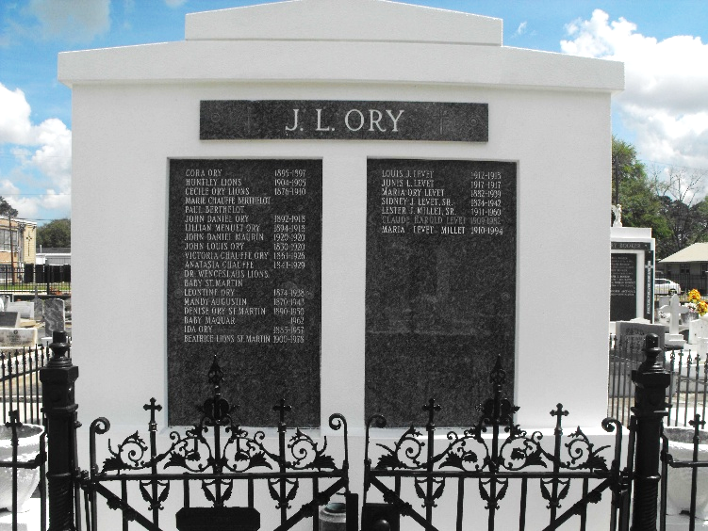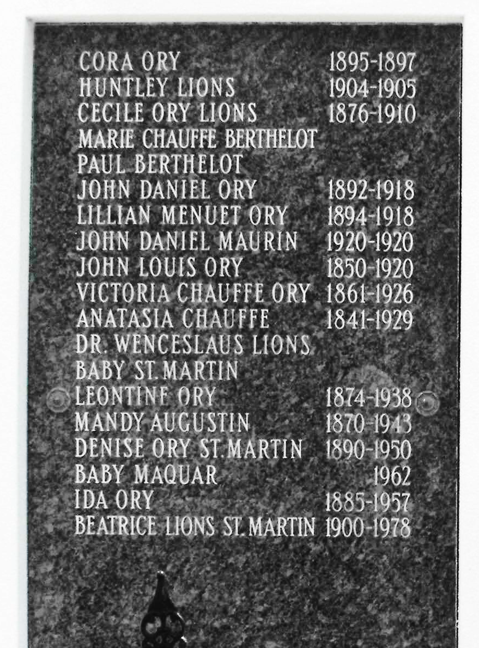
Photos by Mary Agnes Hammett

ORY - At her late residence, San Francisco Plantation, Lions, La, on Monday, April 22, 1957, at 9:45 o'clock a.m., MISS IDA ORY, daughter of the late John L. Ory and Victoria Chauff; sister of Mrs. Henry Maurin Sr of Laplace, La., and the late Mrs. W. L. Lions, Miss Leontine Ory, Mrs. S. J. Levet Sr, Mrs. Charles St. Martin Jr. and Daniel Ory; aunt of Elmer L. Lions, Mrs. Robert St. Martin, Henry C. Maurin Jr., Marion Maurin, Daniel Maurin, Mrs. Alvin Cambre, Mrs. Victor Marquar, Sidney J. Levet Jr., Claude H. Levet, Mrs. Lester .J Millet, Mrs. W. P. Lodrigues and Carl Leslie Levet; aged 74 years 8 months.
Relatives and friends of the family are invited to attend the funeral from the Millet funeral home, Reserve, La, on Tuesday, April 23, 1957, at 9 o'clock a.m., followed by mass at St Peter's church, Reserve, La. Interment in St Peter cemetery.

The Times-Picayune, New Orleans, Louisiana
23 Apr 1957, p 2

