John Daniel Ory
September 16, 1889 – October 15, 1918

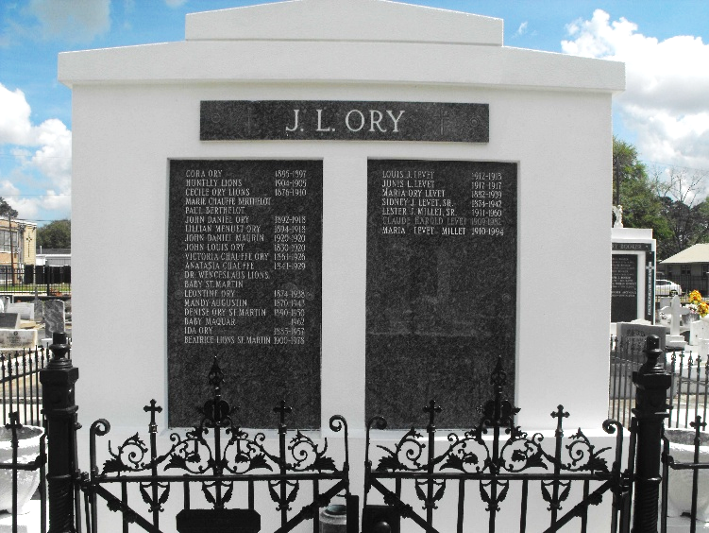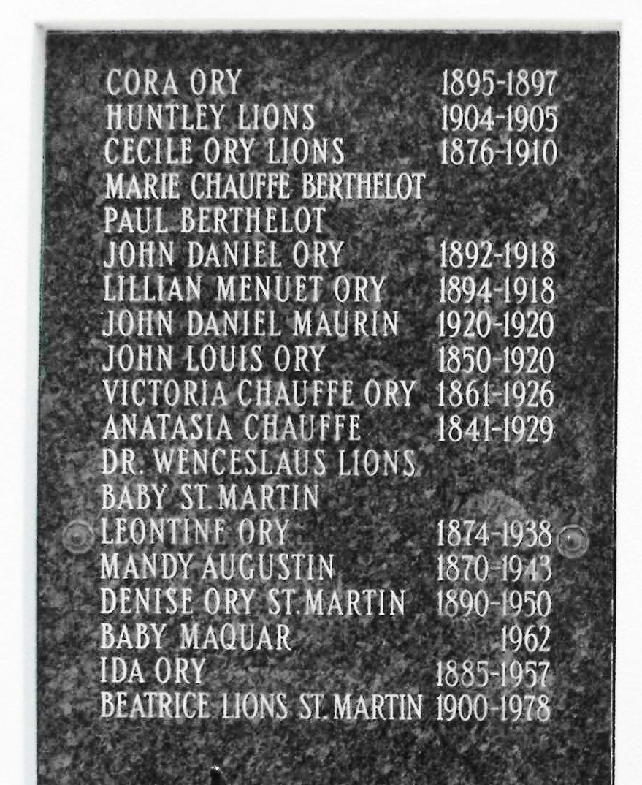
Photos by Mary Agnes Hammett

Died following an attack of influenza and pneumonia at West Pennsylvania Hospital in Pittsburgh, Pennsylvania at age 29 years.
Husband of Lillian Menuet of Gramercy, Louisiana, and son of Mr. and Mrs. John L. Ory of Laplace, Louisiana.
In July he volunteered for Army service in defense of his country and went to A. & M. College at Starkville, Mississippi, where he was in a radio training class. He was transferred to Pittsburgh where he was in training for a commission as band master in the United States band when he died Tuesday, 15 Oct 1918.
He was survived by his sisters, Misses Leontine, Ida and Denise Ory, Mrs. Sidney J. Levet of Lions, Louisiana, and Mrs. Henry Maurin of Laplace. He was predeceased by his first wife, Marie Alida Perilloux.

The Times-Picayune, New Orleans, Louisiana
October 16, 1918

