John Louis Ory
September 12, 1847 – March 21, 1920

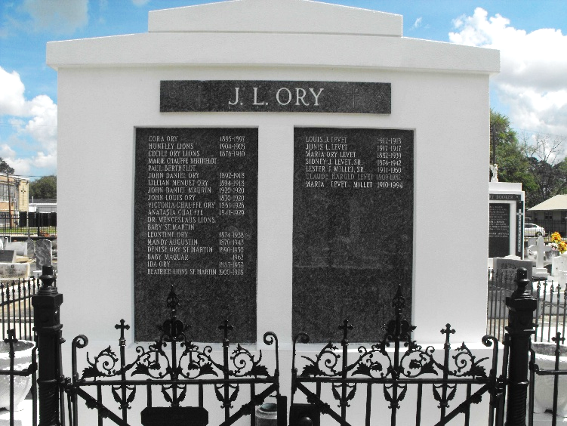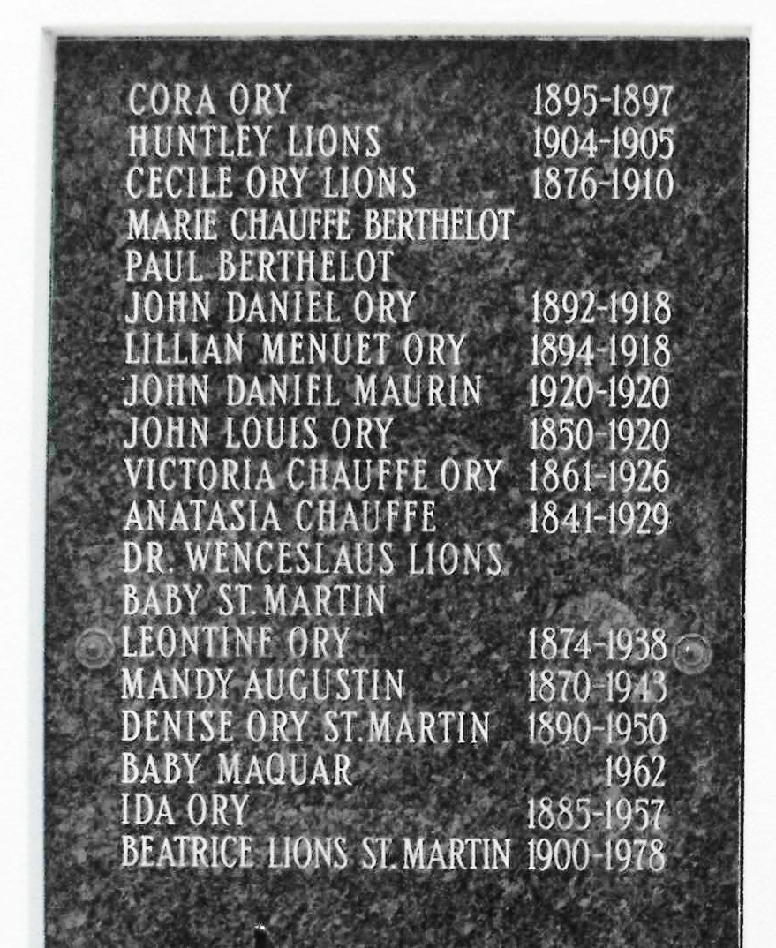
Photos by Mary Agnes Hammett

John L Ory, husband of Victoria Chauffe, died at his residence on Woodland Plantation, St. John the Baptist Parish, Louisiana, on Sunday, 21 Mar 1920, at age 72 years, 6 months, and 9 days. He was born in Lions, Louisiana, on 12 Sep 1847 and has been actively engaged in the sugar industry of the state since early manhood. He was one of the oldest and most widely known, highly esteemed and successful planters and his death is a loss to the community.
In addition to his wife he is survived by five daughters, Misses Leontine and Ida Ory, Mrs. Sidney J. Levet, Mrs. Henry C. Maurin and Mrs. Charles St. Martin Jr. His only son died in the service of his county during the last war.
Funeral services were at St Peter Church in Reserve on Monday, 22 Mar 1920.

New Orleans Item, Louisiana
March 22, 1920
**

"John Louis Ory has devoted his abilities to the vocation of a planter from the time of his boyhood. He received his education at public schools... The Civil War, however, so interfered with his studies as to practically terminate them, and at the age of 14, associated with his brothers, he rented some land and began growing cotton under the tenant system. He did not depend solely upon his cotton crop, and was at all times on the lookout for any odd job that promised an increase of his income. During the years of the war he materially helped himself by hauling contraband material from place to place..."
By the time he was 25, he and his brothers purchased a small plantation and began planting sugar cane. In 1878, the brothers bought Ingleside plantation, on Bayou Lafourche, and some years later added Golden Gate plantation, in Iberville Parish. In 1897, they sold Golden Gate and bought Woodland Plantation. In 1904, they sold Ingleside and added San Francisco and Union plantations in St. John Parish. In 1911, they bought Sarpy plantation in St. Charles Parish, bringing their holdings to about 5,000 acres. Cane and corn were the principal crops. Holdings also included 2 sugar mills.
John scrupulously avoided political entanglements although he did serve as a member of the police jury in St. John Parish. The John L. Ory public school at Laplace is a graceful compliment to the personality and character of a modest citizen. Mr. Ory's home on Woodland plantation is one of the most commodious, attractive and inviting plantation in southwest LA."

Text copied from Les Voyageurs, Vol. XII No. 4, December 1991) From "LA: Comprising Sketches of Parishes, Towns, Events, ..." edited by Alice Fortier (Century Historical Association, 1914)

